Chitosan films with Immobilized Fe2(MoO4)3 as an Efficient Catalyst for the Selective Oxidation of Sulfides to Sulfones

Laura O. Libero*,1 Lara K. Ribeiro,1,2 Juan Andrés,2 Elson Longo,1 Lucia H. Mascaro,1 e Marcelo Assis1,2

1Center for Development of Functional Materials (CDMF), Federal University of São Carlos (UFSCar) Washington Luis Highway, km 235’ 13565-905, São Carlos (Brazil)

2Department of Analytical and Physical Chemistry, Jaume I University Vicent Sos Baynat Avenue 12071, Castellón de la Plana (Spain)

*\*laura.libero@estudante.ufscar.br*

Resumo/Abstract

RESUMO – Neste trabalho foi desenvolvido um catalisador composto pela imobilização de partículas de um semicondutor, Fe2(MoO4)3,em filmes de quitosana para aplicação em reações de oxidação de sulfetos, na ausência de luz. Após otimização da reação, foram obtidas altas taxas de conversão e seletividade para sulfonas, em 30 minutos a 50 ºC, em acetonitrila e 1.2 mmol de H2O2 como oxidante. Ao decorrer do projeto, um amplo espectro de sulfetos, contendo diferentes grupos funcionais, foram oxidados, demonstrando a aplicação regiosseletiva do catalisador frente às condições reacionais brandas e garantindo seu reuso durante 6 ciclos sem perder a performance catalítica. O filme contendo 1 mg de Fe2(MoO4)3 por ml de quitosana foi o que demonstrou maior conversão e seletividade (99%). O sucesso deste processo se dá pela presença de radicais hidroxila (•OH) no meio e o processo do tipo Fenton (Fe3+/Fe2+). Ao final, a aplicação na oxidação de sulfetos a sulfonas comprova o efeito sinérgico entre o semicondutor (Fe2(MoO4)3) e o suporte polimérico (quitosana), permitindo que o design deste material seja mimetizado, variando os semicondutores e os processos de oxidação.

*Palavras-chave: oxidação, reações radicalares, catalisadores com suporte.*

ABSTRACT - This work reports the immobilization of Fe2(MoO4)3 in chitosan films affects the oxidation reaction of sulfide derivatives to sulfates in the dark, resulting in good yields and excellent selectivity. As demonstrated, a variety of substituted sulfides were tolerated even in the presence of oxidative-sensitive functional groups, leading to a regioselective application of the catalyst under mild reaction conditions and guaranteeing its reuse for at least 6 cycles without losing its catalytic performance. Specifically, films containing 1 mg of Fe2(MoO4)3 per ml of chitosan showed a yield and selectivity of 99%. The key success of the selective oxidation was associated with the presence of the hydroxyl radical, ·•OH, and the Fe3+/Fe2+ Fenton-like process. As a proof of concept, the selective oxidation of sulfides to the corresponding sulfones was performed to demonstrate the synergistic effect between Fe2(MoO4)3 and chitosan. This work offers a design strategy for efficient catalysts that may extend to other semiconductors and oxidation processes.

*Keywords: oxidation,·radical reactions,·supported catalysts.*

## Introduction

Sulfones are considered “chemical chameleons” due to the possibility of modulating their reactivity through reaction conditions. (1) For this reason, sulfones had led to different applications of valuable synthetic intermediates in the production of new drugs, agrochemicals, and so on. (2-5) Most of the existing oxidative sulfide procedures have drawbacks, such as high temperatures, extended reaction times and use of large amounts of organic solvents. Thus, minimizing these impacts through the use of cleaner oxidants under mild conditions, and achieving high selectivity and stability becomes essential in the design of new technologies based on efficient catalysts. The use of iron molybdate as a semiconductor catalyst is due to the generation of reactive oxygen species (ROS), consequently opening unfavorable reaction paths. However, these catalysts may become more efficient with a strong framework and reduced environmental impact. In particular, chitosan is a by-product residue of the seafood processing industry and can be used in its polymeric form. In this work, we investigated the immobilization of Fe2(MoO4)3 particles in chitosan polymeric films, given the essential role in catalysis. The films were characterized by X-ray diffraction (XRD), Raman spectroscopy, Fourier transform infrared spectroscopy (FT-IR), diffuse reflectance (DRS), scanning electron microscopy (SEM), atomic force microscopy (AFM) and X-ray photoelectron spectroscopy (XPS). The reaction parameters, i.e., temperature, time, solvent, catalyst loading, and type and amount of oxidant, were optimized according to the highest selectivity for sulfones. The recyclability, stability and scalability of the reaction were evaluated as well. Furthermore, the mechanism of action of the composite was analyzed through scavenger experiments, radical probe mass spectrometry (RP-MS), and electron paramagnetic resonance (EPR) spectroscopy.

## Experimental

*Synthesis of Fe2(MoO4)3*

Fe2(MoO4)3 was synthesized using the coprecipitation (CP) method followed by microwave hydrothermal treatment (MHT). First,1×103 mol of FeCl2.4H2O (98%, Aldrich) and 1×103 mol of Na2MoO4.2H2O (98%, Aldrich) were dissolved in two different beakers containing 50.0 mL of distilled water. After complete dissolution, the FeCl2.4H2O solution was added to the Na2MoO4.2H2O solution under constant stirring at 30°C, resulting in the formation of a darkred precipitate. This precipitate was transferred to a Teflon autoclave for MH treatment (2.45 GHz, maximum power of 800 W) operating at 160°C for 32 min. The final precipitate was washed 5 times with distilled water and dried in a conventional oven at 60°C for 12h. Preparation of catalysts: The chitosan solution was prepared by dissolving 2.0 g of chitosan (Infinitu Tech, medium molecular weight, 1250000>96.5%, degree of deacetylation of 75%) in 100 mL of aqueous solution of glacial acetic acid (P.A., Synth) at 1%(v/v) at room temperature. The solution was left under constant agitation for 24 h at room temperature for the complete dissolution of chitosan. The pH was adjusted to 4.8 through the slow addition of NaOH solution (0.1 M, 98%, Synth) and the resulting solution was filtered using a sintered plate filter no. 0. After this process, Fe2(MoO4)3 was added to the solution of chitosan at concentrations of 1.0, 2.0 and 4.0 mg/mL and the mixture was placed in an ultrasound bath for 15 min. The solution was then transferred to a Petri dish and dried at 40°C for 14 h for film formation. Lastly, these films were cut into discs of 0.5 cm in diameter.

*Catalytic procedure*

Catalytic tests were carried out in 4 mL vials under magnetic stirring at 700 rpm/min. The experimental procedure was performed by dispersing the catalyst in a solution with 0.1 mmol of sulfide substrate and 2 mL of solvent containing 15μL of hexadecane (as an internal standard) followed by the addition of an oxidant to the reaction system. The parameters of catalyst loading (10, 7.5, 5 and 2.5 mg), solvent type (CH3CN, H2O, THF, CH3OH, C2H5OH, C3H6O, C3H7OH and CHCl3), oxidant type (H2O2 (35%, 130v, Neon), TBHP (Aldrich), iodobenzene (98%, Aldrich) and air), oxidant volume (1.2 and 0.6 mmol), time (15, 30 and 60 min) and temperature (30, 50 and 70°C) were optimized during the catalytic process. At the end of the catalysis, an aliquot was taken and diluted in 2 mL of ethyl acetate for analysis on a gas chromatograph (GC, Agilent8860) provided with a flame-ionization detector (FID), using a non-polar (5%-phenyl)-methylpolysiloxane column (AgilentJ & WHP-5). The analyses were performed in duplicate. Experiments with scavengers were carried out following the same procedure under optimized conditions, adding equimolar amounts of scavengers. To analyse the recyclability of the catalyst, the experiment was repeated using the same catalyst 6 times. The catalytic scope was performed using commercial sulfides and sulfones based on thioanisole and thiophene and identified the conversion by GC.

## Results and Discussion

The synthesis of semiconductors nanoparticles (Fe2(MoO4)3) was rapidly achieved with hydrothermal microwave assisted method and its immobilization on chitosan was accomplished, supported by XRD, FTIR and Raman results (Figure 1A, B, C).

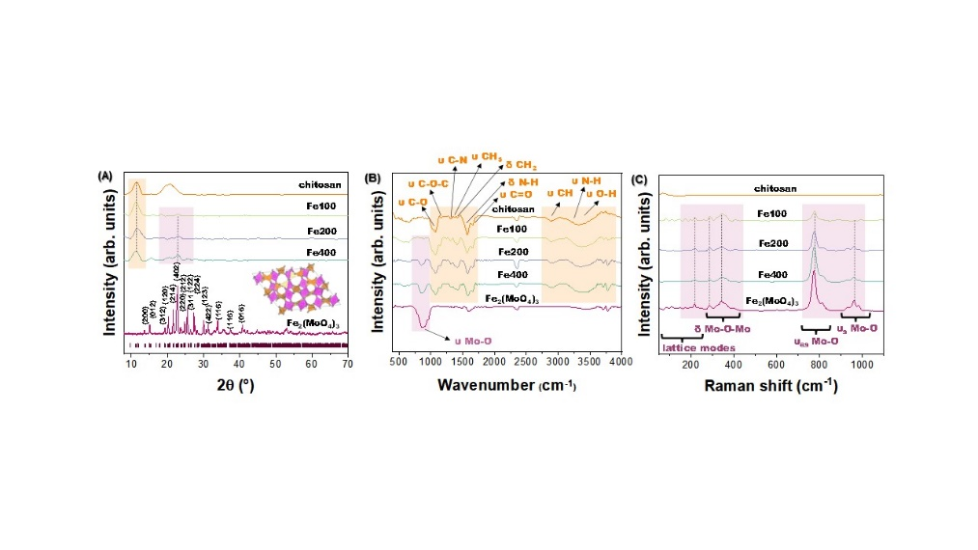

**Figura 1:** A) XRD B) FTIR C) Raman. (6)

Morphologically the hybrid composites were studied by SEM and AFM, demonstrating that the addition of Fe2(MoO4)3 alters the surface of the composites (Figura 1D), leading to an increase in film roughness according to the order: Chitosan<Fe400<Fe200<Fe100. This indicates that the film roughness is inversely proporcional to the amount of Fe2(MoO4)3.

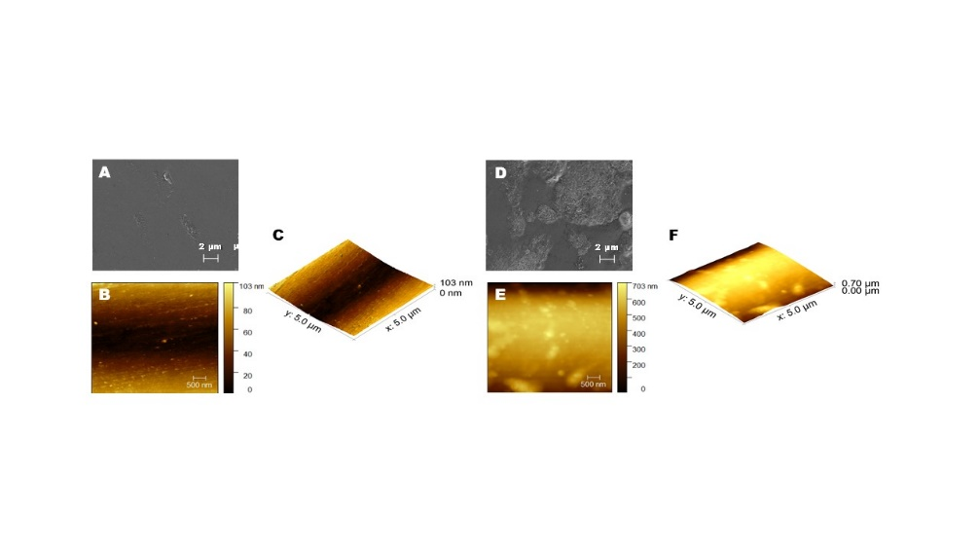

**Figura 2:** A - C) Chitosan and D-F) Fe100. (6)

In terms of catalysis, methylphenyl sulfide (thianisole) was selected as model molecule for the optimization of catalytic conditions. This oxidation can give rise to two distinct products, methylphenyl sulfoxide and methylphenyl sulfone, since the production of sulfone involves high activation energy, becomes a challenge to obtain sulfones in an efficient way. Catalytic conditions such as catalyst composition, temperature, time, type of solvent, and oxidant, amount of oxidant and catalyst loading were taken into account. As a starting point, 0.1 mmol of thianisole, 1.2 mmol of H2O2, 10 mg of catalyst and 2 mL of acetonitrile were used. As shown in Figure 3B, Fe100 reached conversion of 99% at reaction time of 30 min at 50ºC. After, different types of oxidants were tested (Figure 3C), following the early parameters. An interesting result was obtained when testing different solvents (Figure 3D), higher yields of sulfoxide were produced in the presence of n-Octane, opposite from acetonitrile. This shows that by changing the solvent the catalyst can be used to produce both oxidation products. The selectivity and high yields of sulfone were obtained even on scaled reactions (Figure 3E). Stability of the catalyst was carried on by the recycle test, reaching six cycles without losing its catalytic performance. As interest result, the leaching of Fe and Mo was studied by ICP-OES, with maximum leaching of 2.3% per cycle. The catalytic scope demonstrated great conversion (higher than 70%) including different types of sulfides and its functional groups.

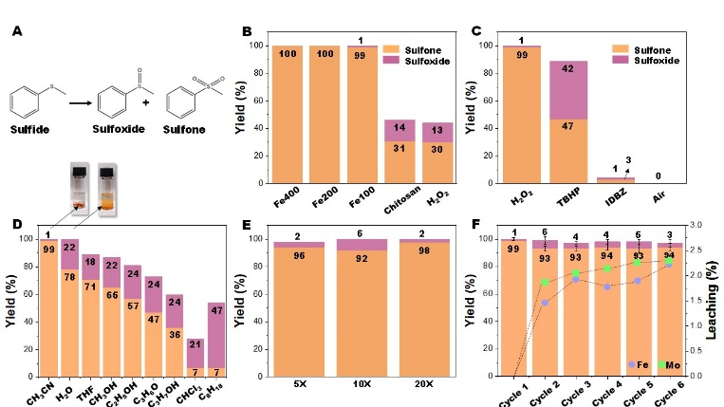



**Figura 3:** A) Reaction scheme B) Reaction performaced at 50ºC and 30 min, using 2 mL of acetonitrile, 10 mg of catalyst and 1.2 mmol of H2O2 C) Optimization of oxidants. D) Optimization of solvents E) Reaction scale-up F) Recycles and leaching of Fe and Mo per cycle, using acetonitrile as solvent G) Catalytic scope. (6)

The mechanism of reaction was investigated from the results of scavenger experiments (Figure 4A), EPR spectroscopy (Figure 4B and D), oxidation of coumarin by •OH (Figure 4C) and oxidation of DMA by 1O2 (Figure 4E). By those results, a mechanism was proposed for an efficient oxidation reaction based on the presence of hydroxyl radical, •OH, and the Fe3+/Fe2+ Fenton-like process.

On that matter, this is a sustainable and efficient catalyst for the selective oxidation of sulfides to sulfones that could be applied using other semiconductors for the development of new catalytic technologies of oxidation processes with low environmental impact. This study has the potential to pave the way for the design of efficient catalysts and future success will be a result of further progress in multiple directions, including the study of their mechanism and preparation.

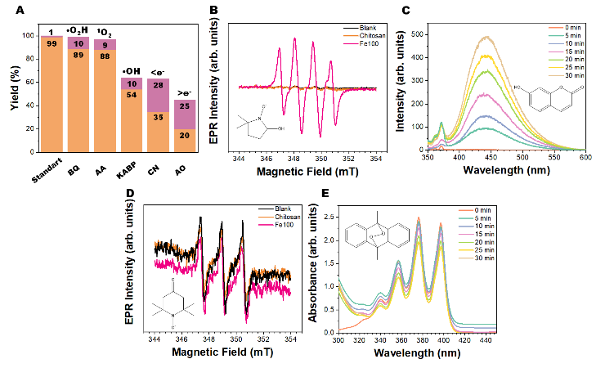

**Figura 4:** A) Scavengers test B) Detection of •OH by EPR using DMPO C) Fluorescence monitoring of coumarin oxidation by •OH D) Detection of 1O2 by EPR and E) UV-Vis monitoring of DMA oxidation by 1O2. (6)

## Conclusion

The main conclusions of the present work are: (i) a practical catalytic system of (Fe2(MoO4)3 immobilized in chitosan films) was successfully developed; (ii) high yields of different kinds of sulfones were obtained selectively in a relatively short time; (iii) the recyclability of the catalyst was considered good since it could be used up to six cycles without losing its performance; (iv) the films containing 1 mg of (Fe2(MoO4)3 per ml of chitosan showed 99% of yield and selectivity to sulfone; and (v) from the results of scavenger experiments, radical probe mass spectrometry and EPR spectroscopy, a mechanism was proposed for an efficient oxidation reaction based on the presence of a hydroxyl radical (•OH) and the Fe3+/Fe2+ Fenton-like process. In broad terms, this is a sustainable and efficient catalyst for the selective oxidation of sulfides to sulfones that could be applied using other semiconductors for the development of new catalytic technologies of oxidation processes with environmental impact.

## Acknowledgements

This work was partly funded by Fundação de Amparo à Pesquisa do Estado de São Paulo – FAPESP (FAPESP CEPID-financecode2013/07296-2), Financiadora de Estudos e Projetos – FINEP, Conselho Nacional de Desenvolvimento Científico e Tecnológico – CNPq (finance code 148751/2022-9), and Coordenação de Aperfeiçoamento Pessoal de Nível Superior– CAPES (financecode 001). M.A. was supported by the Margarita Salas postdoctoral contract MGS/2021/21 (UP2021-021) financed by the European Union-Next Generatio, EU.

## References

1. S. Liang, K; Hofman, M. Friedrich, J. Keller, G. Manolikakes, *ChemSusChem* **2021**, *22,* 4878.
2. X. Lang, W. R. Leow, J. Zhao, X. Chen, *Chem. Sci.* **2015**, *6*, 1075.
3. A. Rajendran, T. Cui, H. Fan, Z. Yang, J. Feng, W. Li, *J. Mater. Chem. A* **2020**, *8*, 2246.
4. V. Trombettoni, A. Franco, A. G. Sathicq, C. Len, G. P. Romanelli, L. Vaccaro, R. Luque, *ChemCatChem* **2019**, *11*, 2537.
5. H. Hao, Z. Wang, J.-L. Shi, X. Li, X. Lang, *ChemCatChem* **2018**, *10*, 4545.
6. L. Libero; L. Ribeiro; L. Granone; M. Churio; J. Souza; V. Mastelaro; J. Andrés; E. Longo; L. Mascaro; M. Assis, *ChemCatChem*, **2023**, e202300421.