The catalysis defined by structural defects and crystallinity: a case study with the catalyst NiMoO₄
Lara Kelly Ribeiro^{1,2*}, Marcelo Assis², Eva Guillámon², Elson Longo¹, Rosa Llusar², Juan Andrés²
¹Center for Development of Functional Materials (CDMF) Federal University of São Carlos (UFSCar) Washington Luis Highway, km 235’ 13565-905, São Carlos (Brazil)
²Department of Analytical and Physical Chemistry Jaume I University Vicent Sos Baynat Avenue 12071, Castellón de la Plana (Spain)
Abstract

ABSTRACT - Chemoselective oxidation of sulfides to sulfone under mild conditions is relevant to industry, but challenging due to the need to establish catalysis mechanisms and optimize various experimental parameters. In this work, the synthesis of NiMoO₄ as efficient and selective catalysts for sulfides transformation into sulfones, focusing on crystallinity studies and structural defects of the material. NiMoO₄ were synthesized by the microwave hydrothermal method and these samples were treated in a microwave furnace for analysis of the influence of the crystalline structural on the selectivity and conversion of these catalysts. Thianisole oxidation was carried out in this work as a source of research for the case study of NiMoO₄. The results show that the defects generated are more important than the crystallinity generated, in this case, to improve selectivity in lower oxidation reaction times. These results open a path to semiconductor oxidation processes in complete darkness, exceeding the limitation of light, required in a wide range of applications.

Keywords: sulfides, semiconductor, catalysis, NiMoO₄

RESUMO- A oxidação quimiosseletiva de sulfetos a sulfonas em condições brandas é relevante para a indústria, mas desafiadora devido à necessidade de estabelecer mecanismos de catálise e otimizar vários parâmetros experimentais. Neste trabalho, relatamos a síntese de NiMoO₄ como catalisadores eficientes e seletivos para transformação de sulfetos em sulfonas, com o foco nos estudos da cristalinidade e nos defeitos estruturais do material. Foram sintetizados NiMoO₄ pelo método de hidrotermal microondas e essas amostras foram tratadas em um forno microndas para análise da influência da estrutural cristalina na seletividade e conversão desse catalisadores. A oxidação do thianisole foi realizada nesse trabalho como fonte de investigação para o estudo de caso da atuação do NiMoO₄. Os resultados demonstram que os defeitos gerados são mais importantes que a cristalinidade gerada, nesse caso, para a melhora da seletividade em menores tempos de reação de oxidação. Estes resultados abrem um caminho para processos de oxidação em semicondutores em completa escuridão, superando a limitação da luz, sendo necessários em uma ampla gama de aplicações.

Palavras-chaves: sulfetos, semicondutores, catalise, NiMoO₄

Introduction
Our group is involved in a research project to investigate the structure, properties and different applications of a family of metallic molibdates (1-2) General Formula AMoO₄ (A =, Cd, Co, Mn, Ni and Zn) or B₂MoO₄ (B = Ag). These compounds combine two metal cations with oxygen anions and balanced load stoichiometry with complex structures and promising properties for a wide range of applications. These structural characteristics give unique properties, which are highly used for various applications, such as solar cells, battery materials, supercapacitors, photocatalysts, water splitting and electrochemical sensors (3-5), due to its advantages, such as unlimited resources, tailored surface, low cost, low toxicity, good chemical stability, great specific capacitance, and environmentally friendly (5-8). Based on these structural characteristics, we imagine that molybdates would be appropriate candidates to accelerate advanced oxidative processes in the heterogeneous medium, even in the dark. To verify the validity of our hypothesis, in this work, we present the investigation of NiMoO₄ structures, such as catalysts for selective sulfides oxidation to sulfoxides or sulfones in the dark.

Experimental

Synthesis of the NiMoO₄
The synthesis of the NiMoO₄ samples was performed using the Microwave-assisted hydrothermal method (MAH) in an aqueous medium. For the pure sample, two separate aqueous solutions were prepared, one containing Na₂MoO₄.2H₂O (0.001 M, Sigma-Aldrich, 99.5%) and the other containing Ni(NO₃)₂ (0.001 mol, Sigma-Aldrich, 99.8%). They were then mixed under constant agitation the Ni(NO₃)₂ solution was added to the Na₂MoO₄.2H₂O solution. The resulting green suspension was submitted to 100 ° C in MAH which was maintained for 60 min. The precipitate was washed several times with H₂O deionized and centrifuged to remove residual ions. After obtaining the powder, thermal treatments were performed to compare the sample obtained in the MAH process with the samples treated in a microwave furnace by 2h varying at 300, 500 and 700 ° C. The schematic the synthesis progress is in Figure 1.

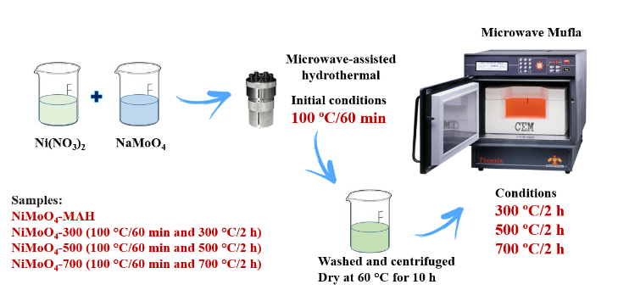
Figure 1. NiMoO₄ synthesis process schematization by MAH followed by microwave furnace treatment.

Oxidation of Thioanisole mediated by NiMoO₄
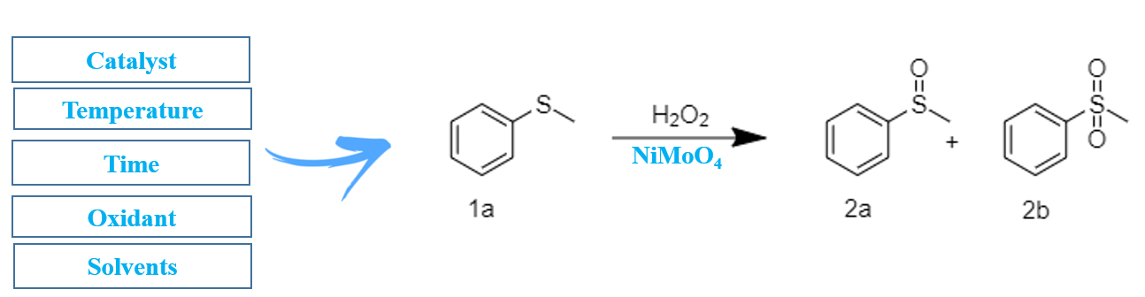
Figure 2. Thioanisole oxidation process (1a) by heterogeneous catalysis (NiMoO₄) with the addition of H₂O₂ as oxidant to obtain sulfoxides (2a) and sulfones (2b).

The catalytic tests were conducted in 4 mL round-bottom flasks with magnetic stirring at 700 rpm/min. The experimental procedure involved dispersing NiMoO₄ in a mixture of 0.1 mmol of sulfide, 2 mL of solvent, and 15 μL of hexadecane as an internal standard. Then, H₂O₂ was added as the oxidant. The reaction conditions such as time, temperature, H₂O₂ amount, solvent, and catalyst loading were varied to optimize the yield and selectivity for the transformation to sulfoxide and sulfone, schematic in Figure 2. The reaction solutions were diluted in 2 mL of ethyl acetate and analyzed by gas chromatography (GC, Agilent 8860) with flame-ionization detection (FID), using a non-polar (5%-phenyl)-methylpolysiloxane column (Agilent J&W HP-5). For catalytic recycles (up to 5 recycles), the experiment was scaled up by a factor of 10 in the best condition.

Results and Discussions

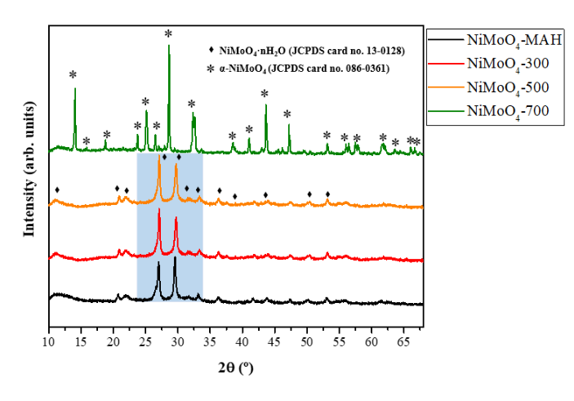
All catalysts were synthesized following the reported procedures and were characterized by the usual techniques, namely DRX, Raman and MEV.

Figure 3. NiMoO₄ samples DRX patterns,

The composition and phase structure of NiMoO₄ synthesized with 100 °C by MAH and microwave furnace were investigated by the spectra of DRX and Raman. NiMoO₄ and NiMoO₄-300, NiMoO₄-500 standards (Figure 3) confirm the presence of hydrated NiMoO₄. The intense peaks at 2θ = 26.4 ° and 29.8 ° correspond to NiMoO₄ indexed by JCPDS 13-0128. The NiMoO₄-700 standards correspond to the alpha phase of NiMoO₄ indexed by JCPDS 13-0128 JCPDS 086-0361.
The Raman spectrum of NiMoO₄-500 and NiMoO₄-700 (Figure 4) displays an intense peak at 961 cm⁻¹ (due to a symmetric Mo–O bond), at 913 cm⁻¹ and at 706 cm⁻¹ (due to an asymmetric Mo–O bond), and a broad peak at 387 cm−1 (due to Mo–O bending). NiMoO₄ and NiMoO₄-300 samples have indications of Mo–O bond, but differences in the observed peaks may be associated with crystalline of the material. Therefore, among the most crystalline hydrated NiMoO₄ samples we can classify the NiMoO₄-500 sample.
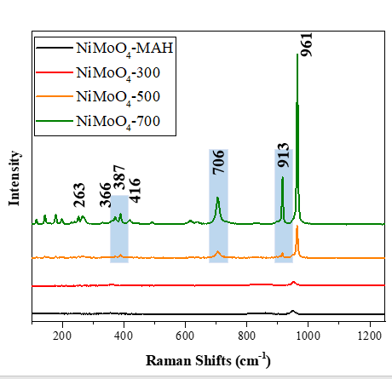

Figure 3. Raman spectra of the samples.

Figure 4 shows us the image obtained from SEM of the NiMoO₄ catalysts. In it, it is possible to observe the change of morphology with the change of the material phase. In addition, a material with different superficies acts differently in catalysis. Exposed surfaces are the main ones for the catalyst performance.

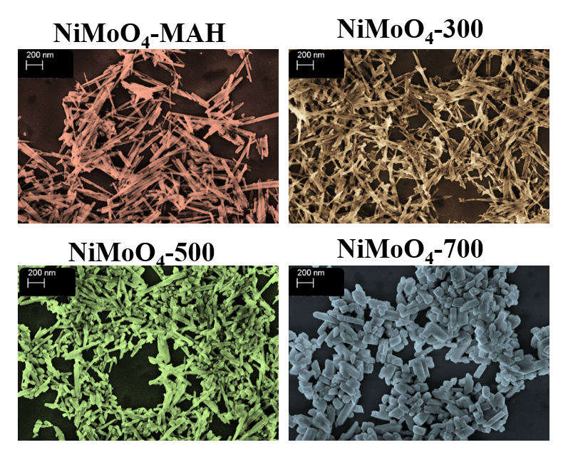
Figure 4. SEM of the NiMoO₄ samples.

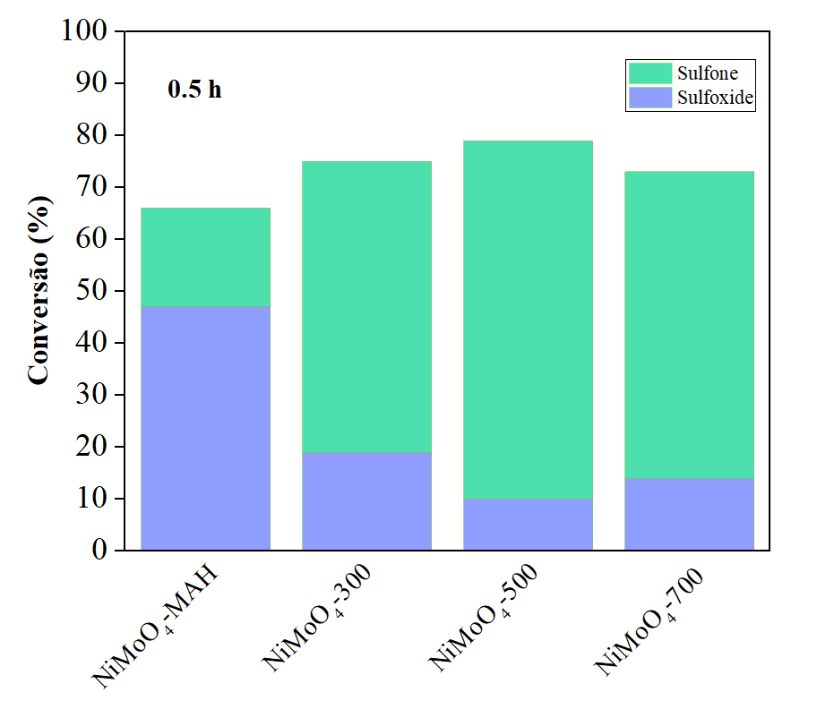
Figure 5. Conversion to sulfones and sulfoxides at 50°C and 30 minutes.

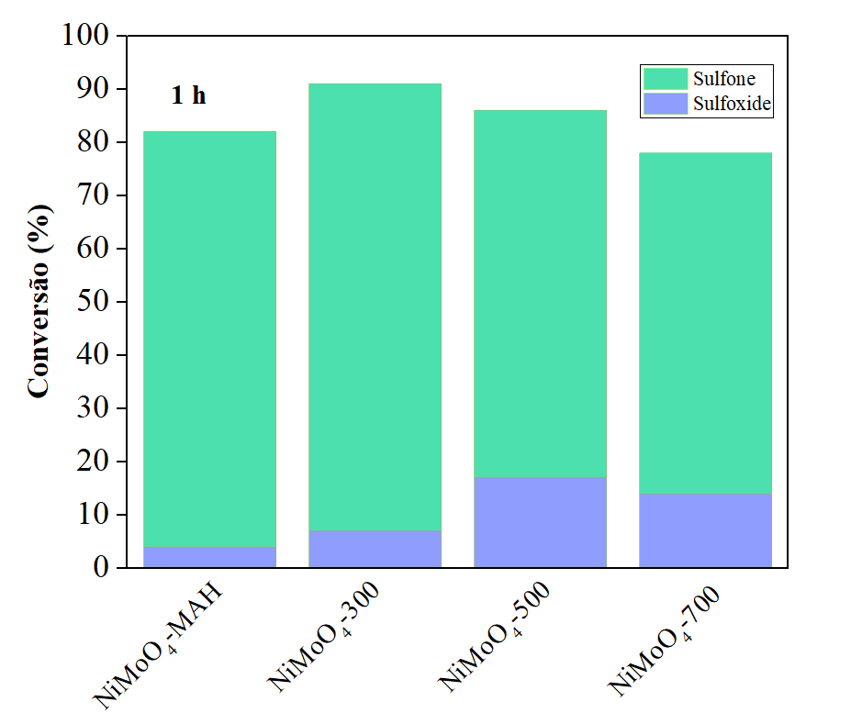
Figure 6. Conversion to sulfones and sulfoxides at 50°C and 60 minutes.

Thianizole oxidation experiments for reaction time optimization revealed that in times of 30 minutes all catalysts have low conversion to the transformation of Thianizole (see Figure 5), the temperature chosen 50 °C was performed by optimizing the temperature. We can verify that by increasing reactional time improvement in catalytic efficiency is observed. In time of 60 minutes (1h) NiMoO₄-700 catalyst has more than 79% conversion and in 90 minutes has 86% conversion (see Figure 6 and 7). Another detail to be observed is the efficiency of the NiMoO₄-300 catalyst which in 60 minutes has 91% conversion and within 90 minutes has more than 99% conversion with high selectivity to sulfones (see Figure 6 and 7).

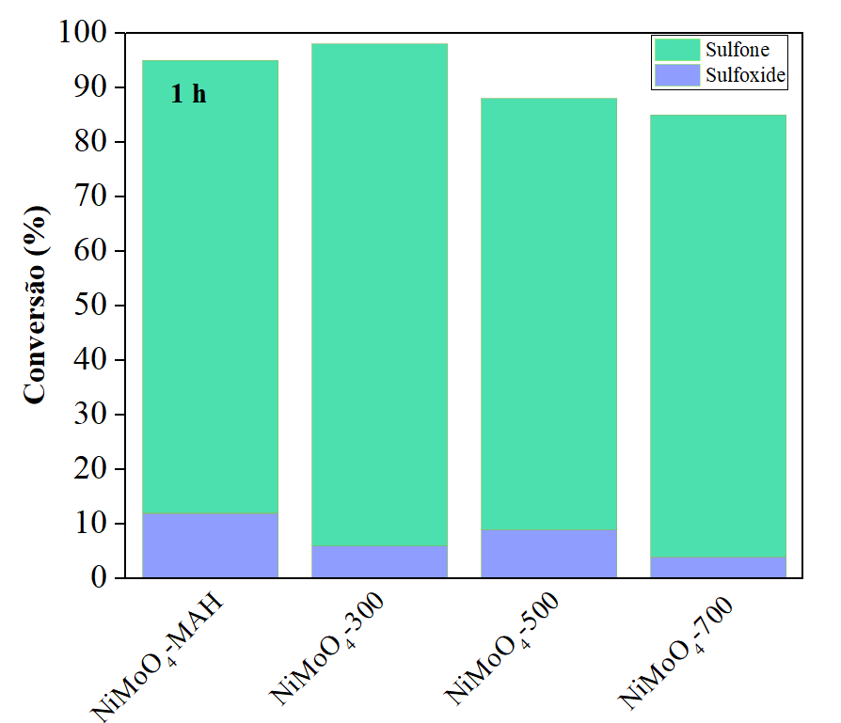
Figure 7. Conversion to sulfones and sulfoxides at 50°C and 90 minutes.

The main indications of the catalytic efficiency of the NiMoO₄-300 material are due to the fact that the material is hydrated and when subjected to the microwave oven can dehydrate forming structural defects and vacancies, even before forming a new structural organization, in this case the alpha phase of the material.

Conclusion
In summary, we have synthesized NiMoO₄ that can be used as catalysts in the selective oxidation of sulfides to sulfones. This study takes full advantage of a catalyst to unravel a multifaceted challenge, not only providing a concise design principle for oxidation processes, but also offering an unrecognized opportunity for the study of new materials that are unexplored by science. intrinsic reactivity of the substrate and how it behaves.

Acknowledgment
This work was partly funded by Fundação de Amparo à Pesquisa do Estado de São Paulo – FAPESP (FAPESP CEPID-financecode2013/07296-2), Financiadora de Estudos e Projetos – FINEP, Conselho Nacional de Desenvolvimento Científico e Tecnológico – CNPq (finance code 148751/2022-9), and Coordenação de Aperfeiçoamento Pessoal de Nível Superior– CAPES (financecode 001). M.A. was supported by the Margarita Salas postdoctoral contract MGS/2021/21 (UP2021-021) financed by the European Union-Next Generatio, EU.

Reference

- B. N. A. Pimentel, et al. Antifungal activity and biocompatibility of α-AgVO₃, α-Ag₂WO₄, and β-Ag₂MoO₄ using a three-dimensional coculture model of the oral mucosa. Frontiers in Bioengineering and Biotechnology, 2022, 10:16.
- P. F. S. Pereira, et al. Study of the annealing temperature effect on the structural and luminescent properties of SrWO4: Eu phosphors prepared by a non-hydrolytic sol–gel process. Journal of alloys and compounds, 2012, 526, 11-21.
- S. K. RAY, J. HUR. A critical review on modulation of NiMoO4-based materials for photocatalytic applications. Journal of Environmental Management, 2021, 278: 111562.
- G. Kianpour, M. Salavati-Niasari, H. Emadi. Sonochemical synthesis and characterization of NiMoO₄ nanorods. Ultrasonics sonochemistry, 2013, 20(1), 418-424.
- F. DURY, E. GAIGNEAUX, P. RUIZ. The active role of CO2 at low temperature in oxidation processes: the case of the oxidative dehydrogenation of propane on NiMoO₄ catalysts. Applied Catalysis A: General, 2003, 242.1: 187-203.
- J. ZHU, et al. Etching-Induced Surface Reconstruction of NiMoO4 for Oxygen Evolution Reaction. Nano-Micro Letters, 2023, 15.1: 30.
- D. GUO, et al. High performance NiMoO₄ nanowires supported on carbon cloth as advanced electrodes for symmetric supercapacitors. Nano Energy, 2014, 8: 174-182.
- L. GUO, et al. Dual-doping NiMoO₄ with multi-channel structure enable urea-assisted energy-saving H2 production at large current density in alkaline seawater. Applied Catalysis B: Environmental, 2023, 320: 121977.

