Acidity evaluation of H-[Al]-RUB-18 by solid-state ³¹P-NMR spectroscopy of adsorbed TMPO in the absence and presence of water
Paulla B. F. Sousa¹; Heloise O. Pastore^{1*}
1 Micro and Mesoporous Molecular Sieves Group (GPM3), Institute of Chemistry, University of Campinas, 13083-970, São Paulo, Brazil.
* Corresponding author: lolly@unicamp.br
Resumo/Abstract

RESUMO - Neste trabalho, o silicato lamelar Na-[Al]-RUB-18 (com razões molares Si/Al = 15, 30, ∞) foi sintetizado e caracterizado por DRX, FRX, TG/DTG, FTIR, e ²⁹Si- e ²⁷Al-RMN. As propriedades ácidas em presença e ausência de água foram determinadas nos materiais ácidos por ³¹P-MAS-RMN de óxido de trimetilfosfina (TMPO) adsorvido como moléculas- sonda, avaliando a natureza (LAS/BAS), força e concentração dos centros ativos. A síntese de Na-RUB-18 ocorreu com uma relação dos sítios Q³/Q⁴ = 2, indicando mais defeitos estruturais devido à maior presença de grupos -SiOH/-SiO⁻, e implicando na incorporação de espécies Al_{Td} e Al_{Oh} em diferentes proporções na sua estrutura. O ³¹P-MAS-RMN indicou sítios ácidos de Brønsted em diferentes concentrações. Uma menor quantidade de TMPO fornece sinais acima de 50 ppm, cuja intensidade aumenta consideravelmente quando a adsorção ocorre na presença de água, sugerindo que a interação do TMPO com a estrutura aumenta nessas condições. Este trabalho inicia os esforços do grupo para a criação de um protocolo consistente de análise de acidez em sólidos lamelares, que se equipare aos existentes para zeólitos.
Palavras-chave: Na-RUB-18, aluminossilicato lamelar, BAS, LAS, TMPO.

ABSTRACT - In this work, the lamellar Na-[Al]-RUB-18 (with Si/Al molar ratios = 15, 30, ∞) was synthesized and characterized by XRD, XRF, TG/DTG, FTIR, and ²⁹Si- and ²⁷Al-NMR. The acidic properties in the presence and absence of water were determined on the acidic materials by ³¹P-MAS-NMR of adsorbed trimethylphosphine oxide (TMPO) as probe molecule, evaluating the nature (LAS/BAS), strength and concentration of the active sites. The synthesis of Na-RUB-18 yielded materials with a Q³/Q⁴ sites ratio = 2, indicating more structural defects due to the larger concentration of -SiOH/-SiO⁻ groups and implying the incorporation of Al_{Td} and Al_{Oh} species in different proportions into its structure. By ³¹P-MAS-NMR, the Brønsted acid sites were identified in different concentrations. A lower amount of TMPO yielded signals above 50 ppm, whose intensity increased considerably when adsorption occurred in the presence of water, suggesting that the interaction of TMPO with the structure is easier in the presence of water. This work initiates the groups’ efforts to create a consistent protocol of acidity analysis in lamellar solids, comparable to those existing for zeolites.
Keywords: Na-RUB-18, lamellar aluminosilicate, BAS, LAS, TMPO.

Introduction
The lamellar silicate Na-RUB-18 is built by the union of [5⁴] cavities that consist of four 5-membered rings of tetrahedral SiO₄ (1). Lamella surfaces have silanolate/silanol groups, the interlamellar space is filled by hydrated Na⁺ charge compensating ions, which by shared edges form 1-dimensional parallel chains in [100, 010] directions (2). The potential to chemically modify the framework of silicates increases the possibility of applications. Thus, isomorphic substitutions of Si⁴⁺ for T-atoms, such as aluminum, to obtain a lamellar solid with acid properties provide new features directed to heterogeneous catalysis (3-5).
[Al]-RUB-18 materials have recently been prepared (4-7). Thus, their acidic properties are not yet fully understood, especially regarding their correlation with lamellar structure and composition when compared to zeolites, their three-dimensional analog. Therefore, several analytical techniques were applied to characterize acid properties in catalyst solids: Hammett acid-base titration, microcalorimetry, thermo-programmed desorption of ammonia, Fourier transformed infrared and solid-state nuclear magnetic resonance spectroscopies (8). The last technique is based on the adsorption/desorption of trisubstituted phosphines or phosphine oxides as probe molecules on acid sites (9-11). ³¹P-MAS-NMR provides quantitative and qualitative evaluations of Brønsted/Lewis acidity and has been widely used because ³¹P is a naturally abundant nucleus (100%) and exhibits high sensitivity in the interactions between the probe molecules and active sites (12-15).
In this work, the acidity in lamellar aluminosilicate with different Si/Al molar ratios has been studied by ³¹P-MAS-NMR in the presence and absence of water. For this purpose, the lamellar silicate sample was synthesized with seed crystals to obtain a Q³/Q⁴ sites ratio different from 1. The post-synthesis method was used to incorporate Al³⁺ in variable amounts (7). The adsorption experiments were carried out with distinct TMPO loadings to evaluate the active sites on silicate and aluminosilicate materials.

Experimental
Preparation of acid lamellar silicate and aluminosilicates
The Na-[Al]- and Na-RUB-18 were synthesized as described in the literature (7), with some modifications. Amorphous silica (Aerosil 200, Sigma-Aldrich) and NaOH (Sigma-Aldrich, pellets, 98%) were added to distilled water under magnetic stirring for 15 min (0.10 mol NaOH:0.05 mol SiO₂:1.36 mol H₂O). The gel was transferred to stainless steel autoclave lined with Teflon and heated for 24 h at 100 °C. After that, amorphous silica (0.16 mol) was slowly added to the Na₂SiO₃ solution and kept under mechanical stirring for 30 min at room temperature until the formation of a homogeneous, viscous, and bright gel. Crystal seeds of Na-RUB-18 (0.8% w/w equivalent to 0.16 mol silica) were added to the mixture and maintained under stirring for another 5 min period. The gel was transferred to a Teflon-lined stainless-steel autoclave and hydrothermally treated in an oven for 336 h at 100 °C. The product (named Na-R18) was washed with distilled water until neutral pH and dried overnight. The post-synthesis method to Al³⁺ incorporation on lamellar silicate was applied in sequence. The Na-R18 was mixed with an amount of Al[OCH(CH₃)₂]₃ (Alfa Aesar, 98%) and ground in a mortar and pestle (Si/Al nominal ratio = 15 and 30). Afterward, the solid mixture was suspended in a 0.1 mol L⁻¹ of NaOH solution (10 mL/g of Na-18). The final mixture was transferred to a stainless-steel autoclave lined with Teflon and hydrothermally treated in an oven for 336 h at 100 °C. The products (named Na-[Al_{x_y}]-R18, with x and y as the Si/Al nominal and experimental ratio values) were washed with distilled water until neutral pH and dried overnight.
The ion exchange procedures were performed by dispersing the lamellar solids in 1 mol L⁻¹ of NH₄Cl solution (100 mL g⁻¹), under magnetic stirring at room temperature for 24 h. Then, the samples were washed with distilled water and filtered until a negative test for chloride ions with AgNO₃ (Synth, 0.1 mol L⁻¹). The solids were dried overnight. This method was employed in triplicate for each sample. Subsequently, a thermal treatment was carried out by ramping the temperature from 20 °C to 200 °C under N₂ (1 °C min⁻¹) and then holding at this temperature for 1 h. The sample was then heated to 300 °C under O₂ (1 °C min⁻¹) and held at this temperature for a further 2 h. The acid samples were named H-R18 and H-[Al_{x_y}]-R18, where x and y are the Si/Al nominal and experimental ratio values.

Structural Characterization
The samples were analyzed by powder x-rays diffraction (XRD) on a Bruker diffractometer (D2-Phaser 2° Gen. model, CuKα radiation, λ = 1.54 Å, voltage of 30 kV, current of 10 mA, detector SSD160-1D, slit of 1 mm), in a range of 2θ = 5° to 50° and at a scan rate of 2° 2θ min⁻¹. The FTIR spectra were collected by using a Thermo Electron Corporation Spectrophotometer (Nicolet 6700 model, detector DTGS), in the mid-infrared region (λ⁻¹ = 400 a 4000 cm⁻¹), by accumulating 128 scans at 4 cm⁻¹ of resolution. The samples were prepared with KBr and pressed into pellets. The elemental analyses (XRF) provided the Si/Al molar ratios and were performed in a Shimadzu (XRF 1800 model, Rh tube, 40 kV and 95 mA). The scan rate was 8° min⁻¹ in a range of 10° to 140°, using a diffraction crystal of LiF and a detector FPC to lightweight elements (Z ≤ 21). The quantification of the elements was performed by the fundamental parameter method. The experiments of solid-state 1D-MAS-NMR were carried out with a Bruker Avance II⁺ 400 MHz Spectrometer (with 10 kHz at 22 °C, probe 2R, rotor of 4 mm). The proton-decoupled ²⁹Si-NMR spectra were obtained at a resonance frequency of 79.459 MHz, π/2 pulse, and 60 s delay, using kaolinite as the reference. The proton-decoupled ²⁷Al-NMR spectra were obtained at a resonance frequency of 104.261 MHz, π/12 pulse, and 2 s delay, using aqueous Al(NO₃)₃ as the reference. The thermal behavior of the samples was investigated using thermogravimetric (TG) and derivative analyses (DTG) operated in SETSYS Evolution SETARAM. The samples (∼14 mg) were heated in a flow of N₂ (16 mL min⁻¹), at a heating rate of 10 °C min⁻¹ from room temperature to 800 °C.

TMPO adsorption experiments and solid-state ³¹P-MAS-NMR spectroscopy
The ³¹P-MAS-NMR technique by adsorption of trimethylphosphine oxide as probe molecules on lamellar materials was employed following the procedure adopted by (12), with adaptations. A portion of 300 mg of acid lamellar solids was placed into a Schlenk and connected to a vacuum line. The samples were heated up to 250 °C for 15 h to remove water and other impurities. The rehydration procedure was applied in the same Schlenk under vacuum for the analysis in the presence of water, heating another cell with a known mass of CoCl₂.6H₂O (Sigma-Aldrich) at 140 °C for 90 min. The water mass in the metallic complex was equivalent to the same quantity missed during the dehydration step of each sample (TG/DTG data – Fig.1). A specific volume of the concentrated (CH₃)₃PO/CH₂Cl₂ solution of 3.69·10⁻² mol L⁻¹ (TMPO - Alfa Aesar / Solvent - Synth, 99.5% anhydrous CH₂Cl₂) was used for each sample, adjusting to achieve different TMPO loading (P/Al molar ratio = 1.4 and 0.5). Afterward, this portion of the solution and 30 mL of CH₂Cl₂ were added to the sample in a dry glovebox under an argon atmosphere, kept at equilibrium in the sealed Schlenk for 1 h, and was again connected to the vacuum line to remove the solvent at 50 °C for 1 h. After that, TMPO@H-[Al_{x_y}]- and H-RUB-18 were treated at 165 °C for 1 h to ensure uniform distribution of the probe molecules on the active sites. Finally, the Schlenk was opened in a dry glovebag under an argon atmosphere, and the TMPO@H-[Al_{x_y}]- and H-RUB-18 were packed into MAS-NMR zirconia rotor (ø = 4 mm) and sealed with a gas-tight Kel-F cap. The proton-decoupled ³¹P-MAS-NMR spectra were obtained at a resonance frequency of 161.9 MHz (Bruker Avance II⁺ 400 MHz, with 10 kHz at 22 °C), π/2 pulse, 20 s delay, and 5400 scans, using concentrated H₃PO₄ as the reference.

Results and Discussion
Structural characteristics of lamellar materials
Results of the structural characteristics of as-synthesized lamellar samples are shown in Fig. 1. In X-rays patterns, the peaks at around 2θ = 7.9° indicate the basal spacing of lamella in the c [001] direction (d₀₀₁ = 1.002 nm to 1.111 nm), and the region 2θ = 15° to 35° relates to the lamella crystal structure (1-2,6-7). The partial isomorphic substitution caused some changes in relative intensity and a slight shift in the peaks, which depended on Si/Al molar ratio. A flat baseline in these curves suggests no amorphization of the RUB-18's structure and the presence of a unique phase, principally after the incorporation of Al³⁺ in high pH. The ion exchange induced variations in the diffraction patterns are characteristic of the RUB-18 structure. The decrease and variation of intensity, the broadening of the peaks, and the reductions in the signal/noise ratio are all in agreement with previous studies of H-RUB-18 (4).
The FTIR spectra of sodium lamellar materials show bands at 1665 cm⁻¹ and 1629 cm⁻¹ are characteristics of bending vibrations of H₂O molecules (δ H-O-H) involved in H-bond each other and interactions with structure compensating cations (Na⁺ ions) in octahedral coordination (5). In addition, the absorption range between 1300 cm⁻¹ to 400 cm⁻¹ contains the external and internal vibrations characteristics of tetrahedral TO₄ (T-atoms = Si or Al) in RUB-18 (7-8). The bands at 1234 cm⁻¹ and 824 cm⁻¹ are the antisymmetric (ν_{asy}) and symmetric (ν_{sy}) stretching vibration of the intertetrahedral Si-O-T bonds. The tetrahedra O-Si-O bonds are signalized by the absorption bands associated with the ν_{asy} and ν_{sy} modes at 1059 cm⁻¹ and 790 cm⁻¹, respectively.
The band at 443 cm⁻¹ is relative to the δ(O-T-O). The ν(Si-O) modes of silanol groups located on the surface of the lamella and involved in extensive H-bond are evidenced by the wide band at 889 cm⁻¹. Finally, the band of double 5-membered rings of the RUB-18 building unity is located in the spectrum at around 620 cm⁻¹.
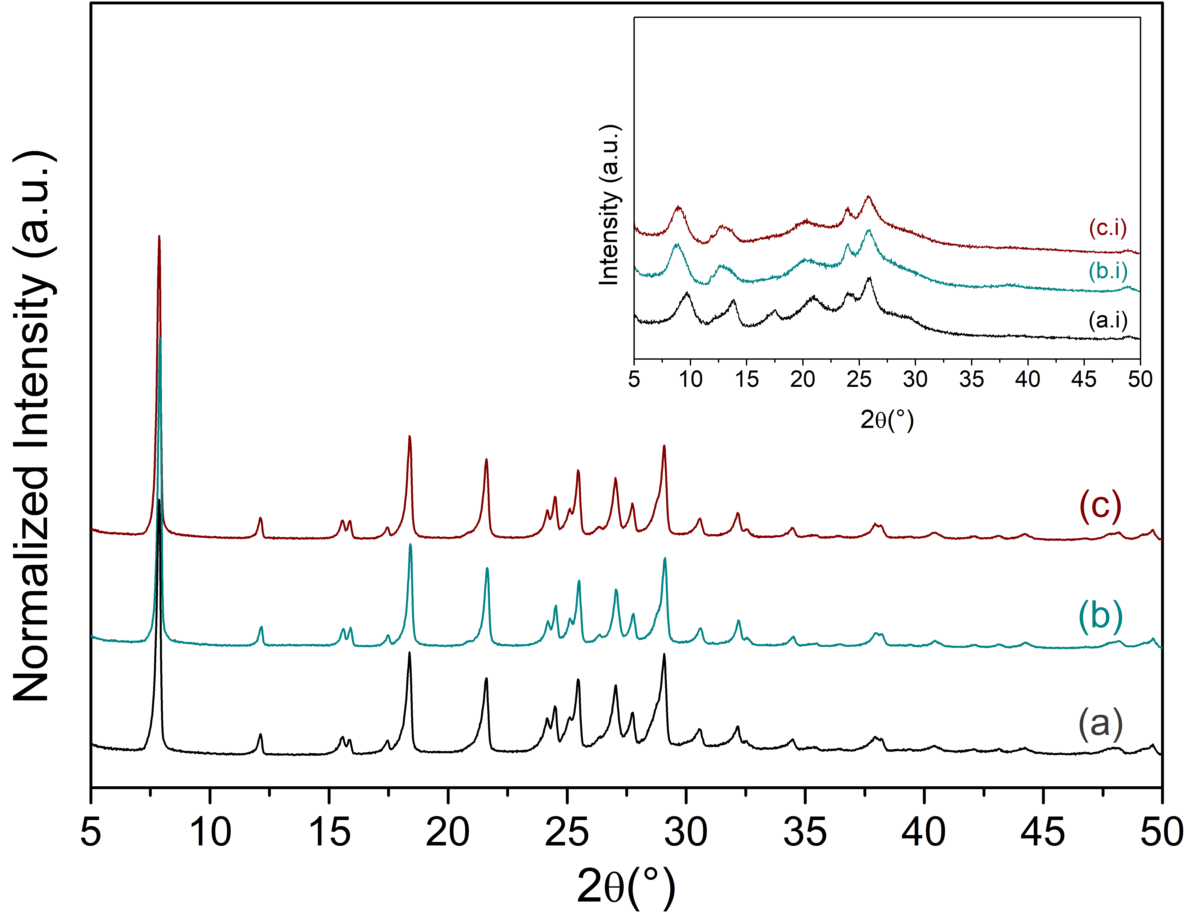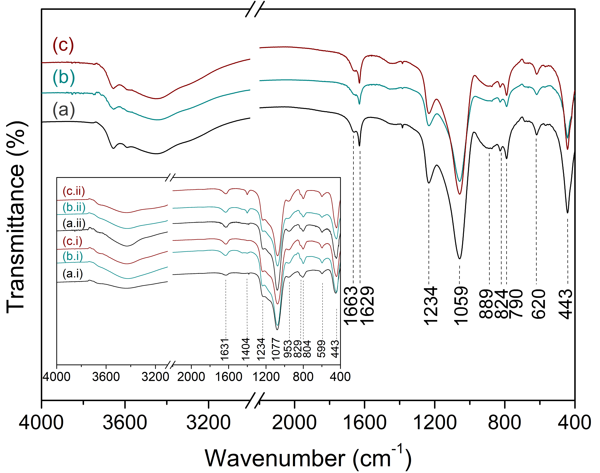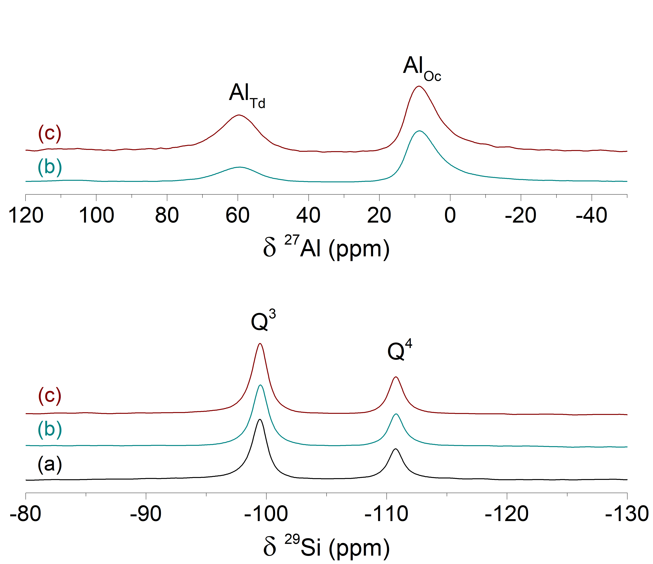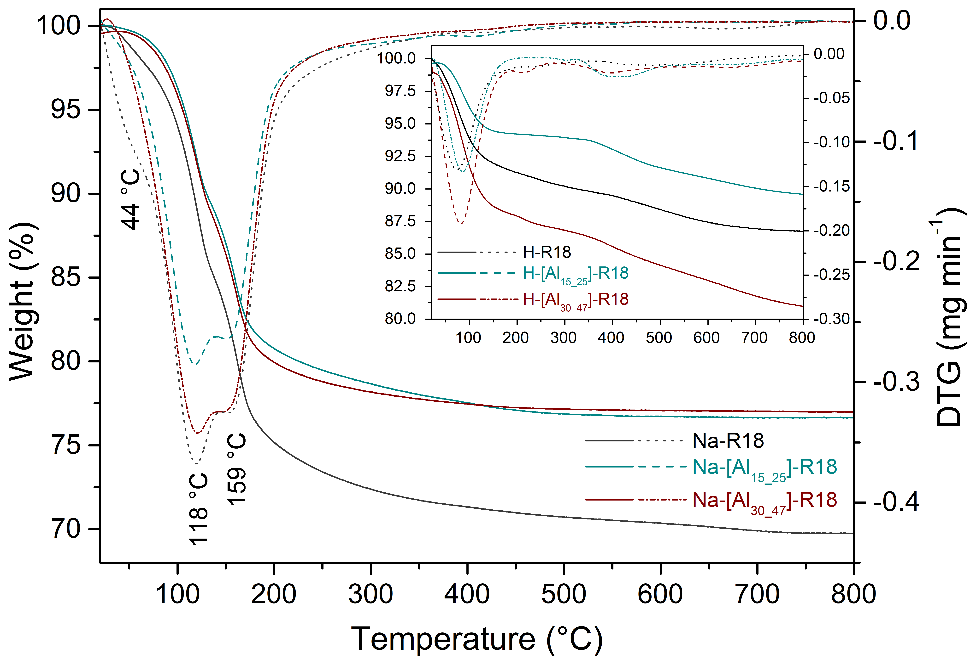
Figure 1. XRD patterns, FTIR and NMR spectra, TG/DTG curves of lamellar samples: (a)Na-R18; (b) Na-[Al_{15_25}]-R18; (c) Na-[Al_{30_47}]-R18. The inner graph corresponds to samples (ii) after ion exchange and (i) acid form.
The FTIR spectra after the ion exchange to obtain the respective acid forms do not exhibit the absorption bands at 1665 cm⁻¹ and 1629 cm⁻¹, just at 1631 cm⁻¹ corresponding to the δ(H-O-H). The appearance of a ν(N-H) band at 1404 cm⁻¹ and its absence after the calcination step confirms the ion exchange with ammonium ions, followed by their decomposition to form the acid material. Other absorption bands with some shifts and shape changes in the region at 1300 cm⁻¹ to 400 cm⁻¹ confirm the maintenance of the RUB-18 structure.
According to ²⁹Si-MAS-NMR spectra (Fig. 1), the two resonance signals at -99 ppm and -111 ppm are typical to Q³ and Q⁴ sites found in the NaRUB-18 framework, or (SiO₄)₃Si-OH/(SiO₄)₃Si-O-Na⁺ and (SiO₄)₄Si species, respectively (1,4-7,17). The Q³/Q⁴ ratio = 2.00 of the Na-R18 sample reveals the presence of a large concentration of silanol/silanolate groups, suggesting structural defects with probable crystal sizes smaller than the standard Na-RUB-18 (Q³/Q⁴ ratio = 1.00) (1). The same resonance peaks after the insertion of aluminum were observed with minor changes in the shape of the peaks (width and height). The process of isomorphic substitution especially occurred on the surface of the lamella, and fluctuations in Q³/Q⁴ molar ratios were caused by using these sites in the Al substitution process.
The crystallization process was changed, providing Na-RUB-18 and Na-[Al]-RUB-18 with different Q³/Q⁴ ratios given by the largest amount of silanol groups in the framework. In this case, the use of crystal seeds of Na-RUB-18 affected the reactional course performed into the same synthesis time. This synthesis technique reduces the induction time by eliminating the nucleation step while accelerating crystallization because it provides a crystallization nucleus in which the product can grow (18). Also, it is possible to exercise control over the final product, such as the distribution of crystal sizes, so the high supersaturation and the use of seeding will produce crystallites of much smaller size (19).
Therefore, the ²⁷Al-MAS-NMR spectra (Fig. 1) reveal the tetrahedral (Al_{Td}) and octahedral (Al_{Oh}) aluminum sites, or (SiO₄)₄Al and (SiO4)₃Al(OH)(H₂O)₂ species, at δ²⁷Al = 60 ppm and 8 ppm, respectively (18). It was observed that the area of the signal corresponding to Al_{Td} decreased when the Si/Al nominal ratio decreased from 30 to 15. According to previous results (7-8), when Q³/Q⁴ ratio = 1.0, samples with Si/Al nominal ratio = 30 or 60 had only tetrahedral aluminum sites (Al_{Td}). In contrast, a high aluminum concentration (Si/Al nominal = 15) formed Al_{Oh} besides Al_{Td}-type species. In the present case, the addition of seeds caused the Na-RUB-18 to decrease in size, creating excess -SiOH sites on the surfaces and favoring the formation of Al_{Oh}.
In Fig. 1, the thermogravimetric curves for sodium samples had the expected thermal behavior in comparison to the literature (6), considering the adjusted synthesis methodology. The sodium lamellar samples lose about 20% to 30 % of their mass in three stages. In the first step, the samples lost H₂O molecules physisorbed on the lamella surface between 20 °C and 100 °C. The strongly adsorbed H₂O molecules were eliminated in two further steps: at 100 °C to 150 °C, molecules that form the hydration shell with Na⁺ ions and are directly bound to them; and at 150 °C to 170 °C, molecules that establish H-bonds with -SiOH/-SiO⁻ groups on the lamella surface. The TG/DTG data of acid samples resembles the one of the sodium samples, the release of water finishes at ca. 250 °C. The loss of 9.33%, 5.91%, and 12.78% of water were found in samples H-R18, H-[Al_{15_25}]-R18, and H-[Al_{30_47}]-R18, respectively. The maximum temperature used in adsorption experiments of probe molecules, in the presence of water, to investigate the acid sites and guarantee the structure maintenance of RUB-18 was 250 °C.

Acid properties analyzed by ³¹P-MAS-NMR
The adsorption experiments were carried out with TMPO because it is more sensitive to the strength of BAS in solid acid catalysts than to LAS (9). The chemical shift range to the reaction products of TMPO with BAS is δ³¹P = 50 - 100 ppm, whereby between 50 ppm and 60 ppm could be used to classify LAS in zeolites (13-14) or -SiOH internal/external groups in zeolite without LAS (12). ³¹P-NMR resonances above 86 ppm have been assigned as the threshold for superacidity (15). The TMPO (M.P. = 140 °C) is extensively used in this process due to its kinetic diameter (0.55 nm) allowing adsorption on many catalysts (10-11), especially on microporous solids and between the lamella of RUB-18 in the acid form, which it has an average interlamellar space of 0.9 nm. Also, this phosphine oxide (proton affinity = 910 kJ mol⁻¹) is an intermediate strong base when compared to other probe molecules applied in acid properties measurements, such as pyridine (proton affinity = 930 kJ mol⁻¹) and ammonia (proton affinity = 854 kJ mol⁻¹) (16).
The ³¹P-MAS-NMR spectra in the absence (Dehyd.) and presence (Hyd.) of water with different P/Al molar ratios are shown in Figs. 2-4. The red curves indicate the results of spectral analysis by Lorentz deconvolution, and the asterisks denote spinning sidebands. No resonance signals were visualized at 31 ppm and 39 ppm associated with mobile and crystalline TMPO, indicating that the probe molecules were physisorbed and chemisorbed with δ³¹P values around at 45 ppm and 50 ppm to 80 ppm, respectively (13).
As shown in Fig. 2, the spectrum for the H-R18 sample with low TMPO loading (P = 50%) exhibits one resonance signal relative to probe molecules physisorbed on different -SiOH sites on the lamella surface at 47 ppm. These groups interact in double bridge by hydrogen bonds without protonating TMPO. Increasing the TMPO loading (P = 140%) causes the appearance of a small resonance peak at 50 ppm due to the small number of probe molecules interacting with -SiOH external groups on the lamella edges. Furthermore, the narrowing and shifting of the physisorbed signal to δ³¹P = 44 ppm can be explained by breaking H-bonds formed by -SiOH groups, resulting in a homogeneous interaction for all sites on the lamella surface. Distinct strengths of interactions between TMPO and silanol sites on RUB-18 (the surface and edges of the lamella) can be explained by structural defects identified by ²⁹Si-NMR spectroscopy (Fig. 1).
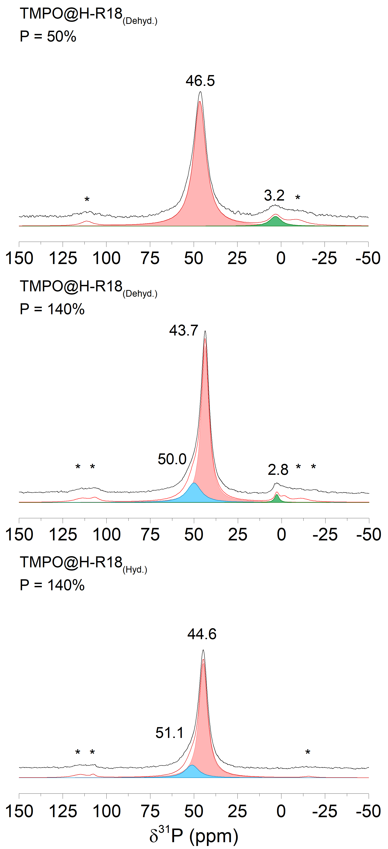
Figure 2. ³¹P-MAS-NMR spectra for H-R18 sample (P = 1/2 of n° of moles of phosphorous used for each equivalent H-[Al_{15_25}]-R18 sample).
In Figs. 3-4, the rise of resonance signals in the BAS region proves the insertion of Al into Na-RUB-18 and the creation of acid sites in the [Al]-RUB-18 framework, with δ³¹P values in the region between 60 ppm and 80 ppm. For both spectra of lamellar aluminosilicates, the reduced TMPO concentration (P/Al ratio = 0.5) allowed better visualization of the signals above 50 ppm. This is reflected in the intensity of the signals when the peak at ca. 45 ppm decreases, and the other ones increase accordingly. Three resonance signals were attributed for the physisorbed (δ³¹P = 45 - 46 ppm) and chemisorbed (δ³¹P = 52 ppm; 67 - 68 ppm) TMPO molecules. The peaks at 45 ppm and 52 ppm are assigned to (Me)₃PO complexes interacting with -SiOH/-AlOH groups on the surface and edges of the lamella. When compared to H-R18_{(Dehyd.)} sample, the presence of Al_{Oh} sites and external -SiOH/-AlOH groups leads to an increase in intensity and a downfield shift of the signal around 50 ppm. The TMPOH⁺···(SiO₄)₃Al-(O⁻)-Si(SiO₄)₃ complexes were identified by the peak at ca. 68 ppm. In general, a high aluminum concentration causes an increase in the total number of acid sites, consequently, a relative increase in signal is observed in the spectra of the dehydrated material. The saturation with TMPO (P/Al ratio = 1.4) results in a shift of the peaks upfield (δ³¹P = 42 - 44 ppm). In addition, the resonance signals above 50 ppm decrease in intensity, which makes it difficult to see the sites of different strengths in this region of the spectrum. The BAS peak shifts downfield with ∆δ³¹P = +2 ppm.
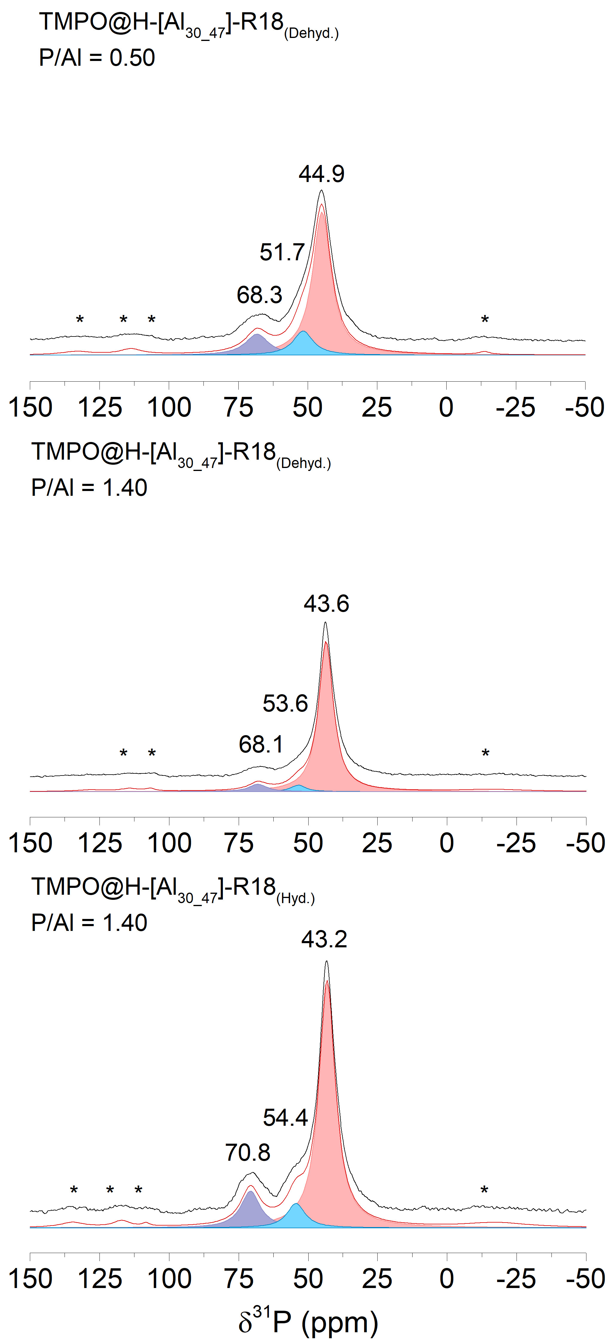
Figure 3. ³¹P-MAS-NMR spectra for H-[Al_{30_47}]-R18 sample.
The TMPO is prone to deliquescence and consequently, the standard procedure requires a dehydration step before the TMPO adsorption (10). Moreover, these experiments were performed in the presence of water to further clarify the acid site behavior in reactions where the water is the final product of specific catalytic reactions, is solvent or is still contained in biomass (5). So, the samples were saturated with water before the adsorption step. The presence of H₂O in the samples with high TMPO concentration shifted the peaks, with ∆δ³¹P = 1 ppm (for all peaks in the H-R18 spectrum) and ∆δ³¹P = 3 ppm (for the BAS peak arising from TMPOH⁺ species) and increased the relative intensity of these signals in the spectra. The resonance values shown indicate large H-bond interactions of probe molecules with these sites in the presence of H₂O molecules, resulting in the considerable deshielding of ³¹P resonances to downfield. The activity of the sites was not affected by the presence of water, suggesting that these sites could be used in catalytic reactions (5).
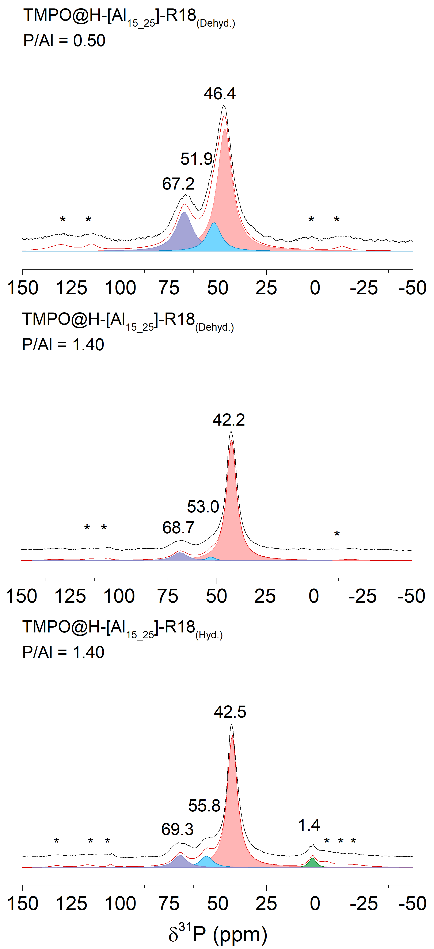
Figure 4. ³¹P-MAS-NMR spectra for H-[Al_{15_25}]-R18 sample.

Conclusion
Na-RUB-18 was synthesized in seeded preparations to produce more silanol groups than usual. The presence of high content of Q³ sites influenced the isomorphic substitution process. The Al_{Td} and Al_{Oh}-type species were identified in different proportions in aluminosilicate lamellar samples. The acid properties of H- and H-[Al]-RUB-18 were investigated by ³¹P-MAS-NMR of TMPO loadings adsorbed as a probe in the presence and absence of water. The spectroscopic analysis revealed three active sites on the RUB-18 lamella: TMPO physisorbed on internal and chemisorbed on external -SiOH/-AlOH groups, and on BAS. The TMPO adsorption analysis in aqueous media suggests the maintenance of acid sites of RUB-18, easing the interactions of the probe molecules with the RUB-18 structure.

Acknowledgement
This work was supported by the São Paulo Research Foundation (FAPESP) (grant 2022/05743-0, project n° 2021/12058-0). The authors thank Dr. Erica Munsignatti for all her support in the development of this work, and the technical team of the Nuclear Magnetic Resonance Laboratory (LRMN), at the Institute of Chemistry/UNICAMP, for the NMR analyses.

References
- S. Vortmann; et al., J. Phys. Chem. B, 1997, 101, 1292-1297.
- M. Borowski; O. Kovalev; H. Gies, Microporous Mesoporous Mater., 2008, 107(1-2), 71-80.
- G.B. Superti; et al., Chem. Mater., 2007, 19, 4300-4315.
- G.P. Campos; et al., New J. Chem., 2020, 44, 9998.
- G.P. Campos; et al., Ind. Eng. Chem. Res., 2021, 60(13), 4794−4805.
- F.S.O. Ramos; et al., Microporous Mesoporous Mater., 2013, 177, 143-150.
- G.B. Báfero; et al., Microporous Mesoporous Mater. 2021, 323, 111189.
- E.G. Derouane; et al., Catal. Rev., 2013, 55, 454–515.
- A. Zheng; et al., Solid State Nucl. Magn. Reson., 2013, 55-56, 12-27.
- D.S. Zasukhin; et al., Pet. Chem. 2021, 61(8), 875-894.
- X. Yi; et al., Nat. Protoc. 2020, 15, 3527-3555.
- D.S. Zasukhin; et al., ACS Omega 2022, 7(14), 12318-12328.
- C. Bornes, et al., J. Am. Chem. Soc., 2021, 143(34), 13616-13623.
- Y. Wang, et al., J. Phys. Chem. C, 2021, 125(17), 9497-9506.
- Zheng, A.; et al. J. Phys. Chem. A, 2008, 112, 4496-4505.
- National Institute of Standards and Technology., NIST Chemistry WebBook. https://webbook.nist.gov/chemistry/, (Accessed: Feb 10, 2023).
- G. Engelhardt; D. Michel; High-resolution Solid-State NMR of Silicates and Zeolites, Wiley, Chichester, 1987.
- C.S. Cundy; P.A. Cox, Microporous Mesoporous Mater. 2005, 82, 1–78.
- Wright, P.A.; Microporous Framework Solids, RSC Publishing, Cambridge, 2008.

