Influence of the synthesis method on La₂Ni_{2-x}Zr_{x}O₆ (x = 0; 1) perovskites for dry reforming of methane

Juliana Bertoldi^{1*}, Camila Emilia Kozonoe¹, Martin Schmal¹
¹LaPCat – Laboratório de Pesquisa e Inovação em Processos Catalíticos. Department of Chemical Engineering of Polytechnic School, University of São Paulo (USP), Av. Prof. Lineu Prestes, 580, Bl.18, CEP 05508-000, São Paulo, SP, Brazil. *jubertoldi@usp.br

ABSTRACT - Perovskite-type oxides La₂Ni_{2-x}Zr_{x}O₆ (x = 0; 1) were synthesized by the polymerization complex method and co-precipitation method. The perovskites were characterized by XRD and TGA aiming to evaluate the influence of the synthesis methods and the introduction of Zr on the catalytic properties for the dry reforming of methane (DRM) reaction. The biggest difference between the synthesis methods was the obtention of La(OH)₃ phases for those synthetized by co-precipitation. DRM performance was better over LN – p catalyst in all the temperature ranges studied, reaching conversions close to 90% and 70% of CH₄ and CO_{2,} respectively, and a H₂/CO ~ 1 at 750°C. LNZr – p catalyst had lower conversions than LN – p, however, CO₂ conversion was higher than CH₄ due to the Zr ability to react with CO₂. Both catalysts synthetized by co-precipitation, LN – c and LNZr – c, provided lower conversions compared to the catalysts synthetized by polymerization complex method. This behavior is probably due to the higher concentration of hydroxyl groups (La(OH)₃).
Keywords: perovskite; double perovskite structure; dry reforming of methane; CO₂ activation.

Introduction
Dry reforming of methane (DRM) is the simultaneous catalytic conversion of the two main greenhouse gases, methane (CH₄) and carbon dioxide (CO₂), into syngas (H₂ + CO) in a molar ratio of H₂/CO =1 (Eq. 1), an ideal feedstock for large scale applications, such as Fischer − Tropsch reactions, hydroformylation, and synthesis of methanol (1, 2).
$\text{C}{\text{H}}_{\text{4}}\text{ + }\text{C}{\text{O}}_{\text{2}}\text{→ }\text{2}\text{CO + 2}{\text{H}}_{\text{2}} {\text{Δ}\text{H}}_{\text{298K }}\text{= 243 kJ mol}\text{-}\text{1}$ (1)
Nickel-based catalysts are the most used systems in methane reforming reactions due to its low cost and its ability of activate CH₄ (1, 3, 4). However, its main drawback is the deactivation caused by Ni particle sintering and carbonaceous formation at high temperatures (2, 3).
Perovskite-type oxides LaNiO₃ (ABO₃) are an alternative to nickel stabilization over metal-oxides systems. The ABO₃ structure can be decomposed into Ni/La₂O₃ by in situ activation, providing better catalytic performance and stability than supported catalysts due to strong metal-support interaction and lanthanum ability to react with coke (5-7).
Partial substitution is a viable way to enhance the catalysts performance by means of the introduction of other metals in the B site (AB_{1-x}B’_{x}O₃). However, if the degree of incorporation is equal to 0.5 and the B' and B cations are sufficiently different in size and charge, a rearrangement can occur, giving rise to the double perovskites A₂BB'O₆ (8).
Double perovskites La₂NiZrO₆ are great candidates as catalysts precursors in DRM due to its intrinsic properties, i.e., La and Zr ability to interact with CO₂ and coke, given oxygen mobility to the support and stability to the Ni particles (9-11). Some studies suggest that structures based on La₂NiZrO₆ are very stable catalysts even at long-term stability tests of 360 hours with no deactivation by carbon deposition (10-12).
In this paper, we investigate the obtention, characterization and catalytic performance at DRM of La₂Ni_{2-x}Zr_{x}O₆ (x = 0; 1) double perovskites over two different synthesis methods.

Experimental
Synthesis Methods.
Polymerization complex method: aqueous solutions of the metallic precursors La(NO₃)₃.6H₂O (Fluka – 99%), Ni(NO₃)₂.6H₂O (Sigma-Aldrich – 97%) and ZrO(NO₃)₂ · xH₂O (Sigma-Aldrich – 99%), were prepared and mixed at room temperature according to the desired stoichiometry ratio to obtain the La₂Ni_{2-x}Zr_{x}O₆ (x = 0; 1) perovskites. Then, a 1 mol/L solution of citric acid (AC) (Sigma-Aldrich – 99%) was incorporated to the resultant metals solution under vigorous stirring in order to obtain an AC/Metals of 1,1. The temperature of the system was raised up to 60°C and maintained under stirring for 30 min. Ethylene glycol (EG) (Sigma-Aldrich – 99%) was added at a AC/EG ratio of 1,5 and the temperature was increased up to 90°C, remaining under this condition until the formation of a polymeric resin. The resin was dried at 110°C overnight and then calcined in two calcination steps; 1) elimination of the organic compounds: calcination at 500°C for 1 hour with a heating rate of 2°C/min under synthetic air. 2) formation of the perovskite structure: calcination at 750°C for 4 hours at a heating rate of 5°C/min under synthetic air (30 mL/min).
Co-precipitation method: the La₂Ni_{2-x}Zr_{x}O₆ (x = 0; 1) perovskites were synthetized by the preparation of a metallic solution containing all metal ions in the appropriated amount. Then, the metallic solution was dropped into a Na₂CO₃ (1,4 mol/L, pH 9) solution at 65°C, leading to the precipitation of the cations. The precipitated remained under stirring for 1 hour at 65°C. The volumetric ratio of Na₂CO₃ (Merck – 99%) and the precursors were maintained at 2:1 to ensure the desired pH. After filtering, the precipitate was washed 10 times with ultrapure water to remove the Na⁺ cations, dried overnight at 110°C, and then calcined at 750°C for 4 hours at a heating rate of 5°C/min under synthetic air (30 mL/min). The samples were named LN – p and LNZr – p to the materials synthesized by polymerization complex method and LN – c and LNZr – c to the samples prepared by co-precipitation method.
Characterization methods
The thermic behavior of the synthetized polymeric resins was analyzed by thermogravimetric analysis. The experiments were conducted in a TG-60H Shimadzu. 5 mg of each sample was placed in a platinum crucible and heated up to 1000°C at a heating rate of 10°C/min under synthetic air flow (50 mL/min). The X-ray diffraction pattern measurements were performed using a Rigaku Mini Flex 600 diffractometer using Cupper radiation (CuKα λ= 1,5418 Å). The diffractograms were recorded in the Bragg angle range of 2 – 90° with a scanning rate of 4 s/step and 0.02º step size.
Catalytic Evaluation. The La₂Ni_{2-x}Zr_{x}O₆ (x = 0; 1) perovskites were evaluated in Dry Reform of Methane (DRM). The tests were realized with a total mass of 100 mg of the sample, 20 mg of silicon carbide (SiC) and a WSHV of 120.000 mL/(g_{cat}h). Before the reaction, the catalysts were reduced under H₂ flow (100 mL/min) at 700°C with a heating rate of 10°C/min, remaining at the final temperature for 1 hour. After the reduction, the temperature was set between 500 and 800°C and the feed stream was CH₄:CO₂:Ar = 0,5:0,5:1 at atmospheric pressure. The exit gas was analyzed by gas chromatography (Perkin Elmer Clarus 500) equipped with a thermal conductivity detector (TCD) and a capillary column (Carboxen 1010) with argon as the carrier gas. The main products identified were H₂, CO, CO₂, CH₄ and ethane.

Results and Discussion
Thermogravimetric analysis. The thermogravimetric profiles of the samples LN - p, LNZr - p, LN – c and LNZr – c are displayed in Figures 1, 2, 3 and 4, respectively.
Figure 1 - Thermogravimetric analysis of LN - p precursor.
Figure 2- Thermogravimetric analysis of LNZr - p precursor.
Figure 3 - Thermogravimetric analysis of LN - c precursor.
Figure 4 - Thermogravimetric analysis of LNZr – c precursor.
The different synthesis methods used in this work led to differences in the decomposition profiles. Both samples synthetized by polymerization complex method had similar thermic behavior, with two main regions of mass loss and two main events in the thermodifferential (DTA) profiles: the first region below 200°C associated with an exothermic event is related to volatile substances from the synthesis and water weakly absorbed (13–15).
The second one, at temperatures close to 400°C and with a strong exothermic peak associated, corresponds to the decomposition and oxidation of the organic template from the synthesis step (13, 14). Besides that, a third region on DTA profile can be seen at temperatures above 500°C indicating the decomposition of intermediate carbonate species to oxides (16). Above 750°C no decompositions or phase transformation are observed, indicating the formation of stable oxides.
On the other hand, co-precipitation method led to a completely different thermic behavior than polymerization complex method. Three well defined regions of mass loss and the predominance of endothermic DTA events are seen. The first one at 260°C can be associated with the removal of structural water especially from lanthanum intermediates (17–19). The second region for the samples obtained by co-precipitation synthesis at the temperature close to 430°C corresponds to the decomposition of metallic intermediates, such as nickel carbonate (20). The last region of mass loss at the temperature ranging from 636 to 686°C is related to the rearrangement of the oxides and the formation of the perovskite matrix (21). However, the materials synthetized by co-precipitation method did not show mass stabilization even at temperatures close to 1000°C, suggesting that phase transformations are still present, as indicated by the slightly endothermic peak in the region of 800°C.
The behavior observed in the materials synthetized by co-precipitation method affected directly the perovskite’s phases and its physical and chemical properties.
XRD analysis. Figures 5 and 6 show the XRD patterns of the samples synthetized by polymerization complex method and co-precipitation method, respectively.

Figure 5 – XRD patterns of the samples LN – p and LNZr – p synthetized by polymerization complex method calcined at 750°C.
Figure 6 - XRD patterns of the samples LN – c and LNZr – c synthetized by co-precipitation method calcined at 750°C.
Comparing both synthesis methods, it is seen that the XRD profiles obtained had differences in crystallinity and crystalline phases identified.
It is noted that the incorporation of Zirconium (Ni:Zr= 1:1) in the sample obtained by polymerization complex method LNZr – p (Figure 5) promoted phases of the rhombohedral double perovskite La₂NiZrO₆ (JCPDS 44-0624) with low crystallinity due to the temperature used ate the calcination step. In fact, La₂NiZrO₆ phases are promoted at high temperatures (>900°C) because of the easier migration of nickel to the bulk leading to the formation of the double structure (11, 22).
Besides that, low crystalline diffraction patterns of the pyrochlore structure La₂Zr₂O₇ (JCPDS 17-0450)) and NiO (JCPDS 44-1159) is verified at the sample LNZr – p. The segregation of these phases is due to the calcination temperature used in this work (750°C), which made the rearrangement of the double structure La-Ni-Zr not completely possible (10, 22).
On the other hand, LN – p showed diffraction patterns of the single perovskite structure LaNiO₃ (JCPDS 34-1077). Besides that, multi-segregated phases were verified, one of them was lanthanum oxycarbonate (JCPDS La₂O₂CO₃ – 48-1113), an intermediate to the perovskite phase. According to the literature, lanthanum carbonaceous compounds is generated by the affinity of lanthanum oxide with CO₂, in this case, from the calcination step (5, 16, 23).
Due to the segregation of lanthanum compounds, diffraction patterns of nickel oxide were verified at 2θ = 37,22 (1 0 1), 43,12 (0 1 2) which suggests that during the crystalline reorganization of the oxides, the amount of lanthanum available in the form of La₂O₃ was not sufficient for the formation of LaNiO₃, leading to segregated NiO phases.
For the samples synthetized by co-precipitation method (Figure 6), it is verified crystalline phases related to the single perovskite LaNiO₃ (JCPDS 34-1077). However, the main difference between the synthesis methods were the obtention of crystalline patterns of lanthanum hydroxide ((La(OH)_{3,} JCPDS 36-1481). This type of material is not expected due to the calcination temperature used. Theoretically, the hydroxide tends to decompose to the oxide in temperatures above to 500°C (24).
There are some hypotheses to the hydroxide formation: i) the high affinity of La₂O₃ to undergo hydroxylation from water present in air under ambient conditions (24, 25); ii) hydroxide formation through a simultaneous cycle of formation, thermal decomposition and regeneration of lanthanum compounds in the presence of water (23), as described by the following equations:
${\text{La(OH)}}_{\text{3} }\text{↔ }\text{LaOOH}\text{ +} {\text{H}}_{\text{2}}\text{O }$ (2)
$\text{2LaOOH ↔ }{\text{La}}_{\text{2}}{\text{O}}_{\text{3}}\text{ + }{\text{H}}_{\text{2}}\text{O}$ (3)
${\text{La}}_{\text{2}}{\text{O}}_{\text{3}}\text{ +}{\text{ 3H}}_{\text{2}}\text{O ↔ }{\text{2La(OH)}}_{\text{3} }$(4)
The occurrence of this cycle could explain the non-stabilization of the compounds synthetized by co-precipitation method even at temperatures close to 1000°C, as seen by the TGA.
Catalytic evaluation. The catalytic performances of the catalysts LN – p, LNZr – p, LN - c and LNZr – c were tested for dry reforming of methane (CH₄:CO₂:Ar = 0,5:0,5:1, T = 500 – 800°C). The DRM experimental results and the equilibrium conversion of CH₄ and CO₂ (26) are displayed in the Figures 7 to 10.
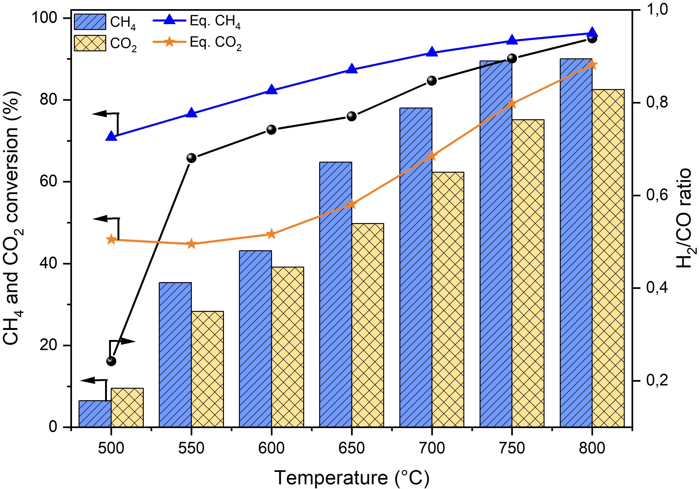
Figure 7 - Catalytic evaluation of DRM over LN – p.
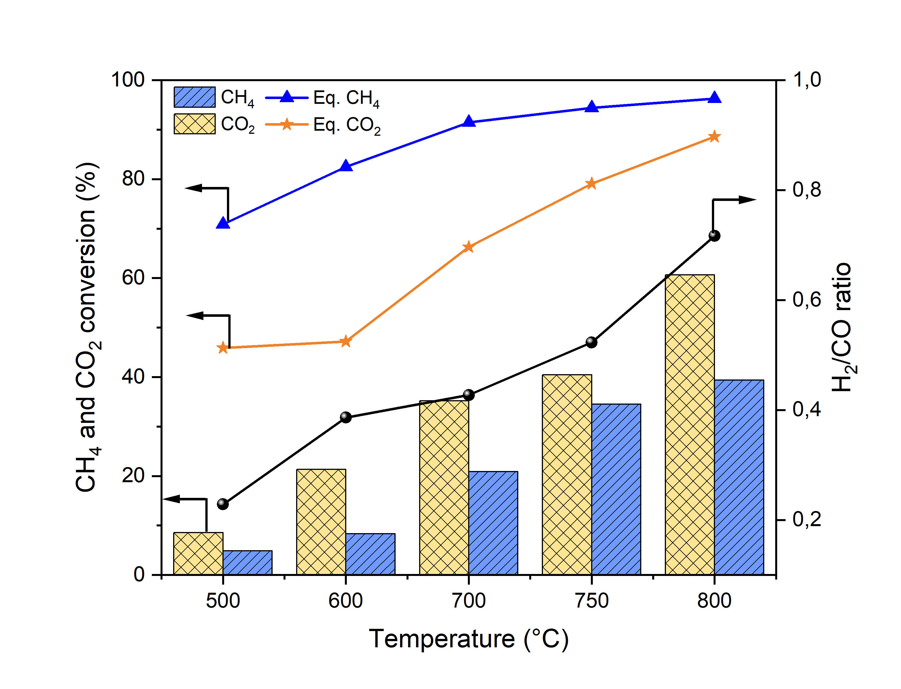
Figure 8 - Catalytic evaluation of DRM over LNZr – p.
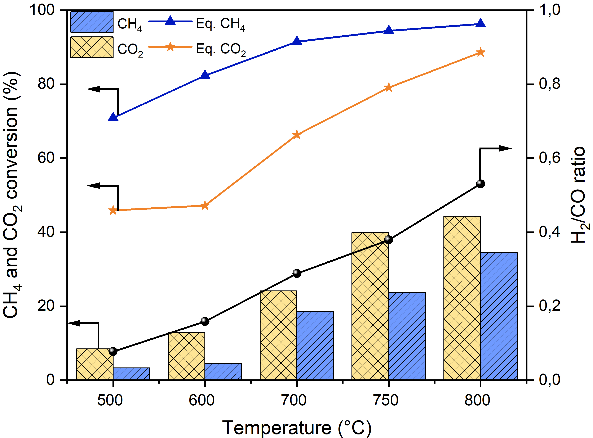
Figure 9- Catalytic evaluation of DRM over LN – c.
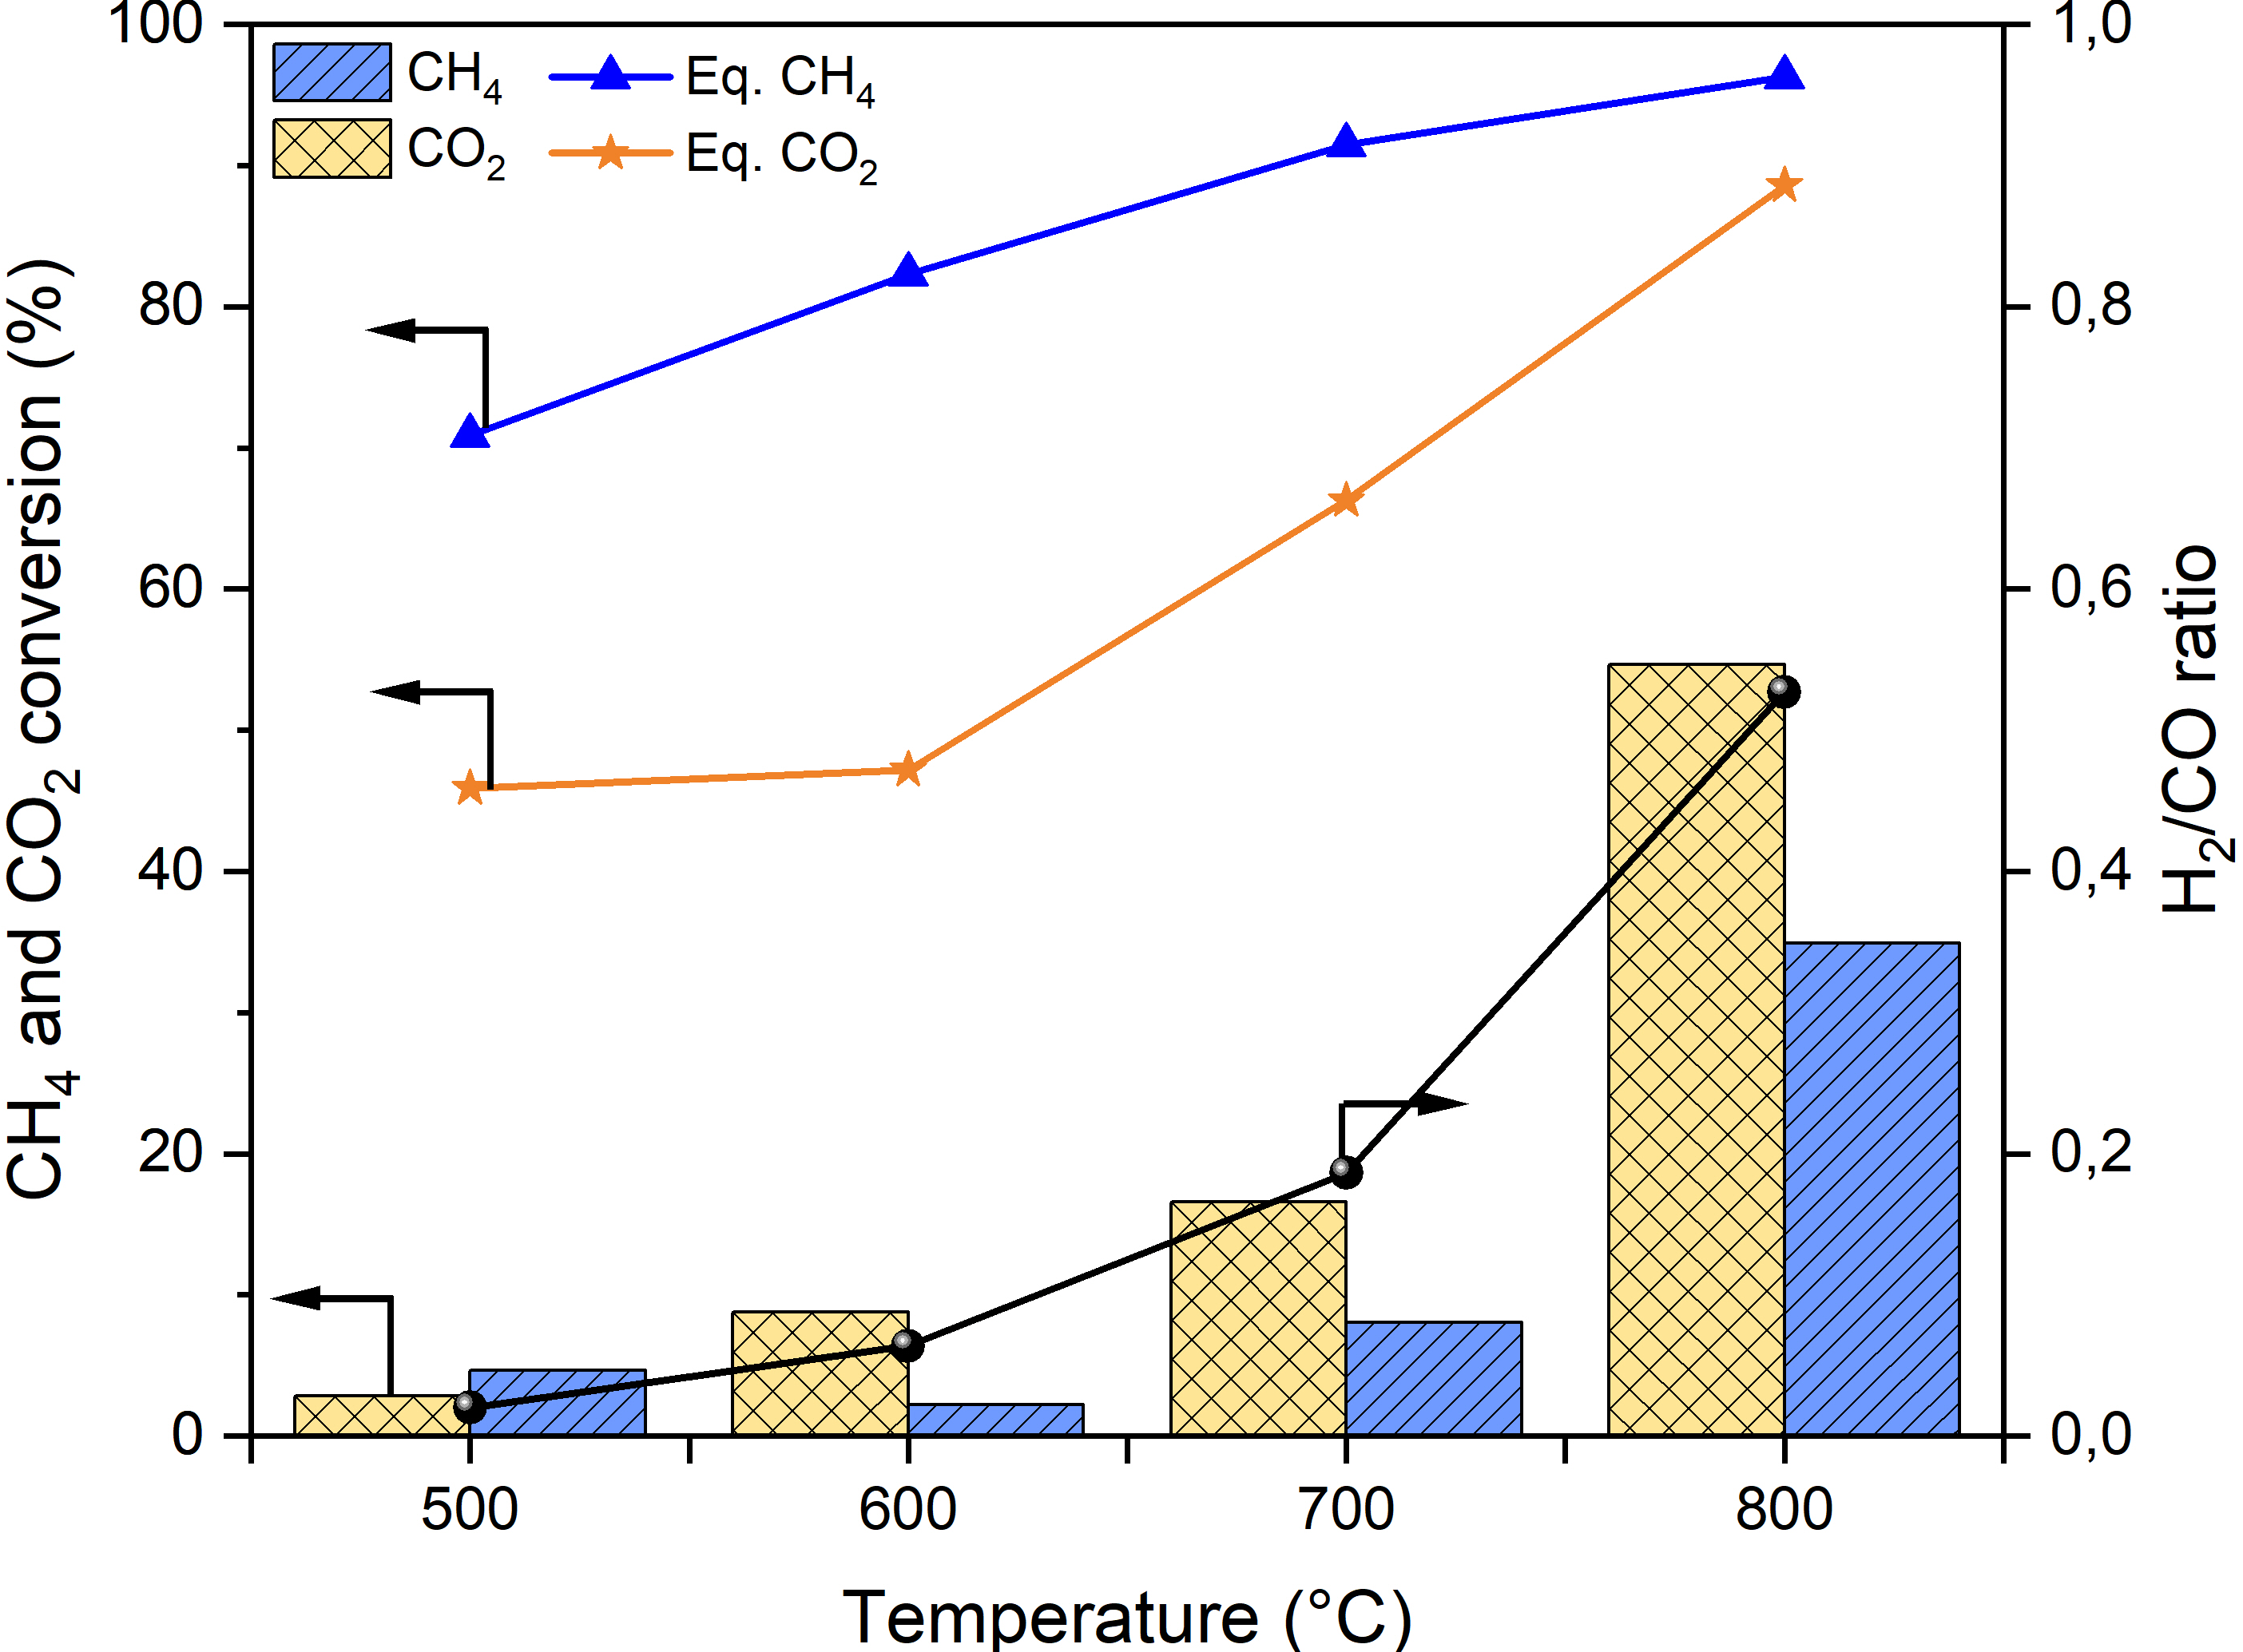
Figure 10 - Catalytic evaluation of DRM over LNZr – c.
As expected, higher CH₄ and CO₂ conversions, and H₂/CO ratio are obtained while the temperature of the reaction was increased, indicating that the temperature is crucial in DRM (27, 28).
Among all catalysts evaluated on DRM, LN – p (Figure 7) presented better catalytic performance than the other catalysts also investigated, reaching conversions close to 90% and 70% of CH₄ and CO₂ in temperatures above 750°C and H₂/CO ratio close to 1. According to Kehres et al. (28) and Ranjekar & Yadav (29), syngas ratios close to 1 are obtained by means of the occurrence of Reverse Water Gas Shift reaction at high temperatures (RWGS – Eq. 5).
$\text{C}{\text{O}}_{\text{2}}\text{ + }{\text{H}}_{\text{2}}\text{ → CO + }{\text{H}}_{\text{2}}\text{O }{\text{ΔH}}_{\text{298K}}\text{ = 41 kJ mol}\text{-1}$ (5)
The water generated in RWGS reacts with CH₄ via steam reforming of methane (SRM - Eq. 6), giving additional H₂ and CO in a syngas ratio of 3 (30).
$\text{C}{\text{H}}_{\text{4}}\text{ + }{\text{H}}_{\text{2}}\text{O → CO + }{\text{3H}}_{\text{2}} {\text{ΔH}}_{\text{298K }}\text{= 207 kJ mol}\text{-}\text{1}$ (6)
Despite the low conversion of both CO₂ and CH₄ at 500°C, it is observed higher conversion of CO₂ suggesting the occurrence of side reactions, such as RWGS, which may justify the shift of the selectivity profile to CO and a low syngas ratio (H₂/CO = 0,24) (31, 32).
On the other hand, LNZr – p (Figure 8) presented lower catalytic performance on DRM than LN – p, reaching 34% and 65% of CH₄ and CO₂ conversions, respectively, at 800°C. The results obtained in this work agreed with the studies of Ma et al. (11) during the partial oxidation of methane with the same structure, in which the authors evaluate the influence of the calcination temperature and crystallinity of the double perovskite in the methane conversion at temperatures ranging from 550 to 750°C.
The results obtained by Ma et al. (11) indicate that the crystallinity of the double perovskite affects directly the conversion of the inlet gases on the reaction, suggesting that calcination temperatures above 900°C is needed to favor the formation of the double structure which leads to better catalytic performance, independently of the reaction temperature used.
LNZr - p provide higher conversions of CO₂ than CH₄ at all temperature ranges studied. This observation could be explained by the introduction of zirconium in the perovskite structure and its ability to provide structural vacancies that promote the adsorption and conversion of carbon dioxide to other compounds (28, 33), through the following equations:
$\text{C}{\text{O}}_{\text{2(gas) }}\text{+ }{\text{*}}^{\text{O-}} {\text{→ CO }}_{\text{(Z}{\text{r}{\text{O}}_{\text{x}}}^{\text{*}}\text{)}}\text{ + }{\text{O}}_{\text{(Z}{\text{r}{\text{O}}_{\text{x}}}^{\text{*}}\text{) }}$(7)
$\text{2C}{\text{O}}_{\text{2(gas) }} {\text{→ C}{\text{O}}_{3}^{2-} }_{\text{(Z}{\text{r}{\text{O}}_{\text{x}}}^{\text{*}}\text{)}}\text{ + }{\text{ CO }}_{\text{(Z}{\text{r}{\text{O}}_{\text{x}}}^{\text{*}}\text{)}}$ (8)
${\text{ C}{\text{O}}_{3}^{2-} }_{\text{(Z}{\text{r}{\text{O}}_{\text{x}}}^{\text{*}}\text{)}} ↔ {\text{ CO }}_{\text{(Z}{\text{r}{\text{O}}_{\text{x}}}^{\text{*}}\text{)}}+\text{2}{\text{O}}_{\text{(Z}{\text{r}{\text{O}}_{\text{x}}}^{\text{*}}\text{) } }$(9)
${\text{ CO }}_{\text{(Z}{\text{r}{\text{O}}_{\text{x}}}^{\text{*}}\text{)}}\text{→ C}{\text{O}}_{\text{(gas) }}$ (10)
(ZrO_{x}* = ZrO_{x} surface site and *^{O-} = lattice oxygen)
Despite the similar behavior between LN-c and LNZr – p, the results differ strongly from LN – p, with the same nominal composition. Independently of the reaction temperature, LN – c presented CO₂ conversions higher than CH₄, indicating the presence of basic sites from La(OH)₃ that facilitated the adsorption, activation and conversion of CO₂ by means of a higher concentration of hydroxyl groups, as also seen by Li et al. (34).
According to the literature, medium-strong basic supports accelerate CO₂ activation and inhibit the formation of carbon from CH₄ decomposition via the increase of oxygen mobility. The oxygen mobility helps the coke interaction with the support, leading to CO formation through Boudouard reaction (Eq. 11) (35–37).
$\text{C + C}{\text{O}}_{\text{2}}\text{ ↔ 2CO }\text{Δ}{\text{H}}_{\text{298}}\text{ = + 172 kJ mol}\text{-1}$ (11)
The influence of the basic sites is clearly seen in the catalyst LNZr – c. Although the catalytic performance was poor, at higher temperatures (800°C) the CO₂ conversion was much higher than CH₄, indicating that this behavior is due to not only by the high concentration of hydroxyl groups, but also to the partial substitution of Ni by Zr (28, 33, 35–37).
In summary, comparing both synthesis methods, the nickel content is the limitant factor. In the catalysts without nickel substitution, higher conversion of both reactants are achieved, suggesting that the major concentration of active sites of nickel led to a increase in the CH₄ decomposition while La₂O₃ is responsible by the interaction with CO₂ (38–41).

Conclusions
The different synthesis methods led to catalysts with different properties and catalytic performances. Co-precipitation method result in samples with no mass stabilization and La(OH)₃ phases, while polymerization complex method had an oxide mixture and a low crystallinity phase of the double structure La₂NiZrO₆ to LNZr - p.
DRM performance was better over LN – p, reaching conversions close to 90% and 70% of CH₄ and CO₂ and a H₂/CO ~ 1 at 750°C. The results suggest that the nickel content in the catalysts is a crucial factor in DRM, leading to higher conversions of the inlet gases.

Acknowledgements
This study was financed in part by the Coordenação de Aperfeiçoamento de Pessoal de Nível Superior - Brasil (CAPES) Finance Code 001 and by Conselho Nacional de Desenvolvimento Científico e Tecnológico (CNPQ) Processo Nº 156589/2022-2.

Referências
[1] L. Xu et al., ChemCatChem, 2019, 11, 2887–2899.
[2] Q. Huang et al., ChemCatChem, 2017, 9, 3563–3571.
[3] P. Delir Kheyrollahi Nezhad et al., Catal. Sci. Technol., 2022, 12, 4, 1229–1244.
[4] J. Guo, H. Lou, H. Zhao, D. Chai, and X. Zheng, Appl. Catal. A Gen., 2004, 273, 75–82.
[5] N. Bonmassar et al., ACS Catal., 2020, 10, 1102–1112.
[6] M. A. Salaev, L. F. Liotta, O. V. Vodyankina, Int. J. Hydrogen Energy, 2022, 47, 4489–4535.
[7] Z. Bian, Z. Wang, B. Jiang, P. Hongmanorom, W. Zhong, S. KawiRenew. Sustain. Energy Rev., 2020, 134, 110291.
[8] X. Xu, Y. Zhong, and Z. Shao, Trends Chem., 2019, 1, 410–424.
[9] A. S. Al-Fatesh et al., Catalysts, 2019, 9, 473.
[10] S. Bhattar et al, Ind. Eng. Chem. Res., 2019, 58, 19386–19396.
[11] Y. Ma et al., Fuel, 2020, 265, 116861.
[12] E. le Saché, et al. Applied Catalysis B: Environmental, 2018 236, 458–465.
[13] J. Bertoldi, K. T. de Campos Roseno, M. Schmal, V. D. Lage, G. G. Lenzi, R. Brackmann, Int. J. Hydrogen Energy, 2022, 47, 31279–31294,
[14] K. T. C. Roseno, R. Brackmann, M. A. da Silva, M. Schmal, Int. J. Hydrogen Energy, 2016, 41, 18178–18192.
[15] M. Popa, Solid State Ionics, 2002, 151, 251–257.
[16] H. Fjellvåg, O. H. Hansteen, B. G. Tilset, A. Olafsen, N. Sakai, H. Seim, Thermochim. Acta, 1995, 256, 75–89.
[17] T. I. M. Vaz, S. M. Gurav, and A. V. Salker, Indones. J. Chem., 2021, 21, 1244.
[18] B. Kucharczyk, J. Winiarski, I. Szczygieł, K. Adamska, Ind. Eng. Chem. Res., 2020, 59, 16603–16613.
[19] L. Tepech-Carrillo et al., J. Nanomater., 2016, 2016, 1-7.
[20] M. A. Rhamdhani, E. Jak, P. C. Hayes, Metall. Mater. Trans. B Process Metall. Mater. Process. Sci., 2008, 39, 218–233.
[21] S. M. de Lima, J. M. Assaf, Mater. Res., 2002, 5, 329–335.
[22] D. J. Haynes, D. Shekhawat, D. A. Berry, J. Zondlo, A. Roy, J. J. Spivey, Ceram. Int., 2017, 43, 16744–16752.
[23] E. Haibel, E. Füglein, A. S. Schulze, D. Walter, J. Therm. Anal. Calorim., 2019, 138, 3571–3575.
[24] P. Fleming, R. A. Farrell, J. D. Holmes, M. A. Morris, J. Am. Ceram. Soc., 2010, 93, 1187–1194.
[25] E. Haibel, S. Berendts, D. Walter, J. Therm. Anal. Calorim., 2018, 134, 261–267.
[26] M. K. Nikoo, N. A. S. Amin, Fuel Process. Technol., 2011, 92, 678–691.
[27] D. P. Minh et al., Hydrogen Supply Chains, Catherine Azzaro-Pantel, Ed.; Elsevier Ltd., 2018; 111–166.
[28] A. M. Ranjekar, G. D. Yadav, “J. Indian Chem. Soc., 2021, 98,. 100002.
[29] J. Kehres et al., J. Phys. Chem. C, 2012, 116, 21407–21415.
[30] C. Jensen, M. S. Duyar, Energy Technol., 2021, 9, 2100106.
[31] L. N. Huang et al., Energy and Fuels, 2022, 36, 5102-5151.
[32] K. Wittich, M. Krämer, N. Bottke, S. A. Schunk, ChemCatChem, 2020, 12, 2130–2147.
[33] A. M. O’Connor, F. C. Meunier, J. R. H. Ross, Stud. Surf. Sci. Catal., 1998, 119, 819–824.
[34] X. Li, D. Li, H. Tian, L. Zeng, Z.-J. J. Zhao, J. Gong, Appl. Catal. B Environ., 2017, 202, 683–694.
[35] M. A. A. Aziz, A. A. Jalil, S. Wongsakulphasatch, D. V. N. Vo. Catal. Sci. Technol., 2020, 10, 35–45.
[36] F. Morales Anzures et al., Int. J. Hydrogen Energy, 2021, 46, 26224–26233.
[37] G. Mallikarjun, T. V. Sagar, S. Swapna, N. Raju, P. Chandrashekar, N. Lingaiah, Catal. Today, 2020, 356, 597–603.
[38] C. A. Schwengber et al., J. Environ. Chem. Eng., 2016, 4, 3688–3695.
[39] W. S. Dong, H. S. Roh, K. W. Jun, S. E. Park, Y. S. Oh, Appl. Catal. A Gen., 2002, 226, 63–72.
[40] Y. J. O. Asencios, E. M. Assaf, Fuel Process. Technol, 2013, 106, 247–252.
[41] Z. Alipour, M. Rezaei, F. Meshkani, J. Energy Chem., 2014, 23, 633–638.

